## BPM Installation Guide

# Revision

|  |  |  |  |
| --- | --- | --- | --- |
| Date | Version | Description | Author |
| 10/30/2012 | 0.00 | Initial Draft | Sreenivasulu Gali  Scott Keling  Sreeja Muralidharan  Chris Krone |

Contents

BPM Installation Guide 1

Revision 2

Download the Oracle BPM Suite 3

Installing the Database 3

Installing Oracle WebLogic Server 10

Creating a Database 17

Installing Repository Creation Utility 28

Installing JDeveloper 11g 40

Installing SOA Suite 11.1.1.6.0 47

Creating Weblogic domain and configuring SOA suite 56

Updating JDeveloper 66

Installing OSB 70

### ****Download the Oracle BPM Suite****

1. Download the Oracle Business Process Management Suite 11g from the following url:

<http://www.oracle.com/us/technologies/bpm/suite/overview/index.html> .

1. Expand the ‘Download‘ button and then proceed to the download page by clicking on ‘Download Oracle BPM Suite’.
2. Accept the license agreement and expand the ‘Prerequisites & Recommended Install Process’ for Release 11gR1 (11.1.1.6.0).
3. Download all the softwares listed to your local machine.

### Installing the Database

1. Download the oracle database from link mentioned in the section above.

Note: Sometimes, the links for database download redirects to incorrect page. So please download the database alone from this alternate link:

<http://www.oracle.com/technetwork/database/enterprise-edition/downloads/112010-win32soft-098987.html> .

1. Extract the files and click on win32_11gR2_database_1of2\database\setup.exe .
2. Enter the Oracle email id or deselect the email option and click on ‘Next’.

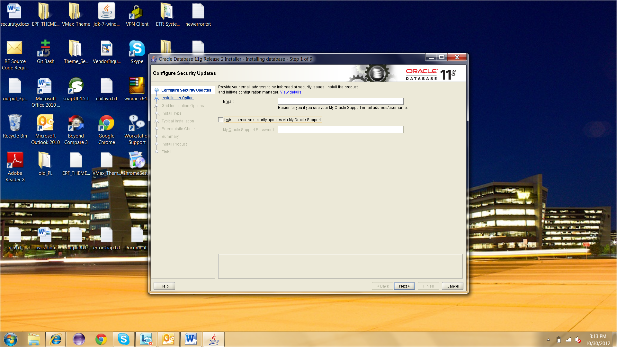

1. Select radio button ‘Install database software only’ and click ‘Next .

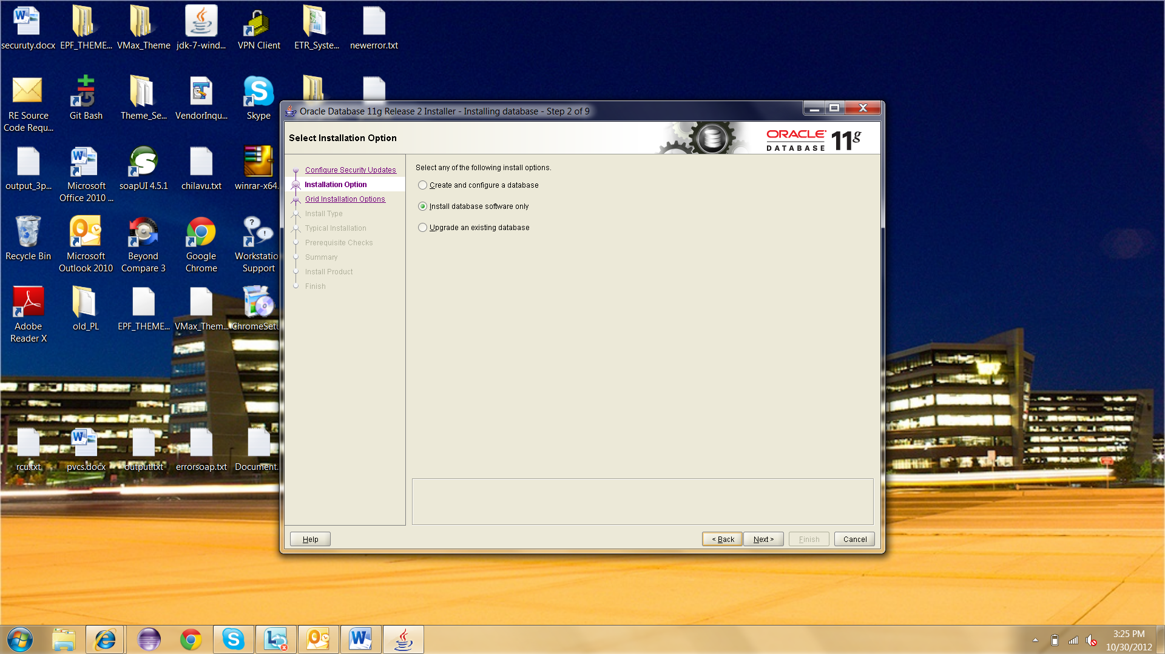

1. Select radio button ‘Single instance database installation’ and click ‘Next’.

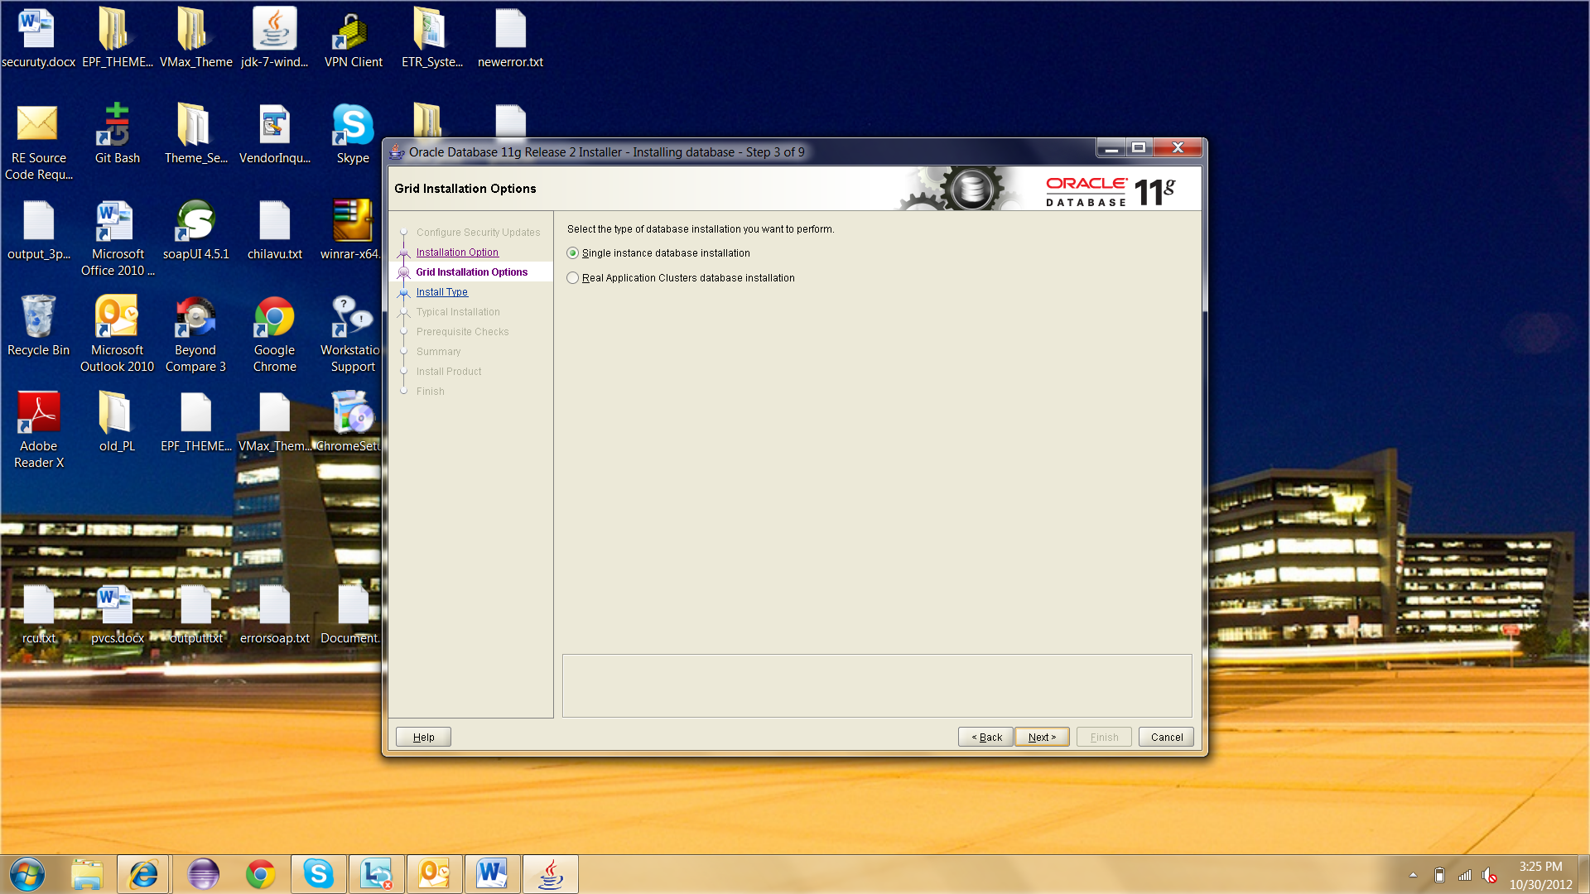

1. Click ‘Next’.

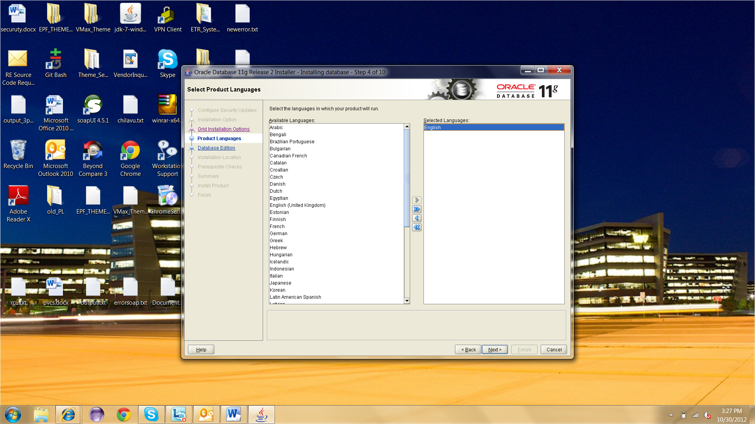

1. Click ‘Next’.

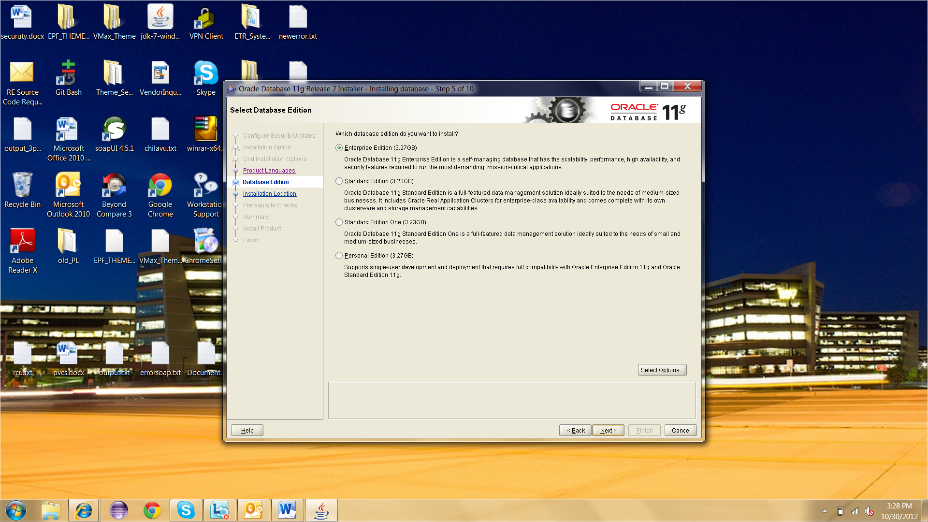

1. Click ‘Next’.

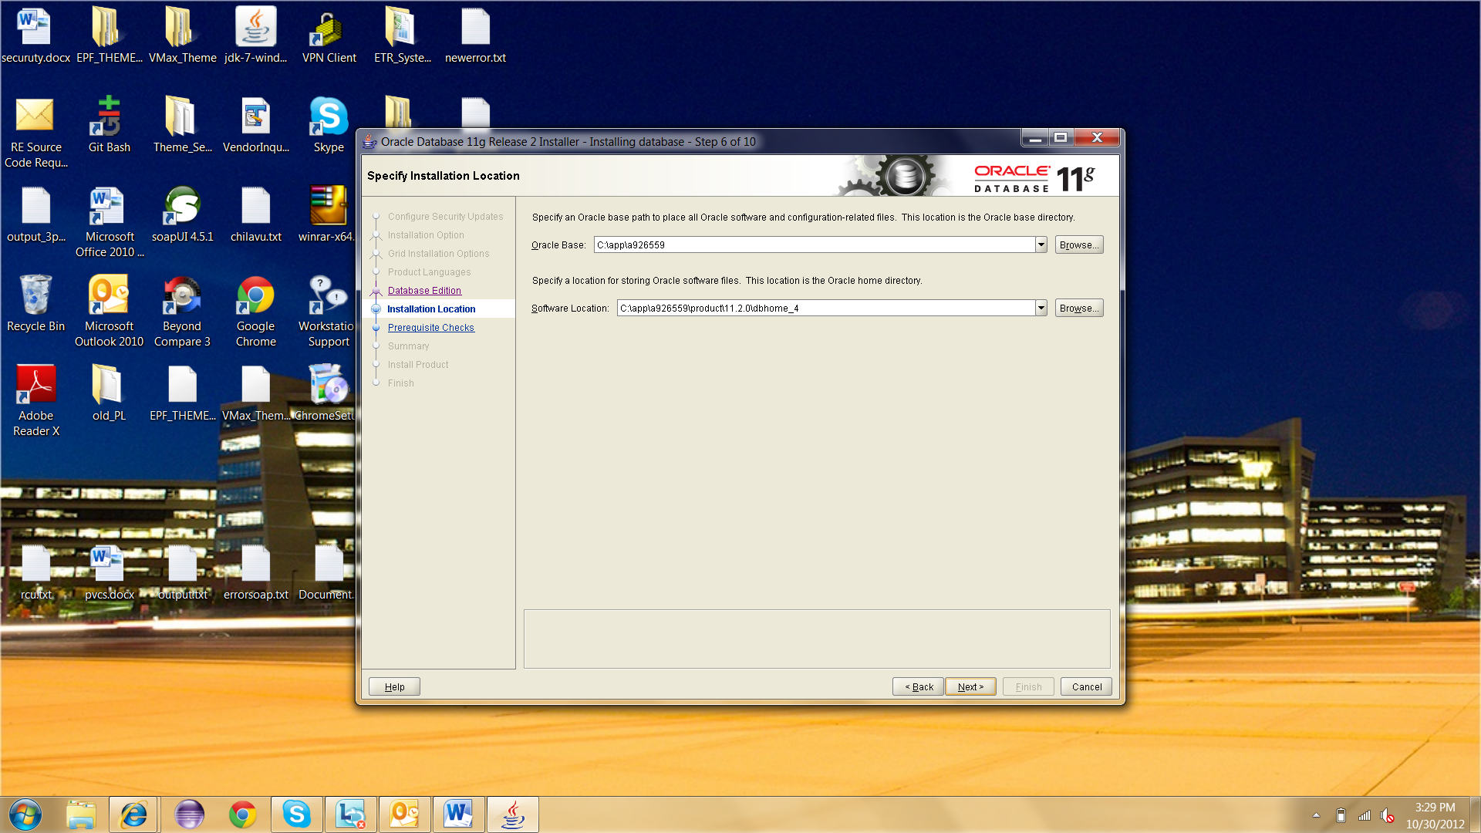

1. Click ‘Finish’.

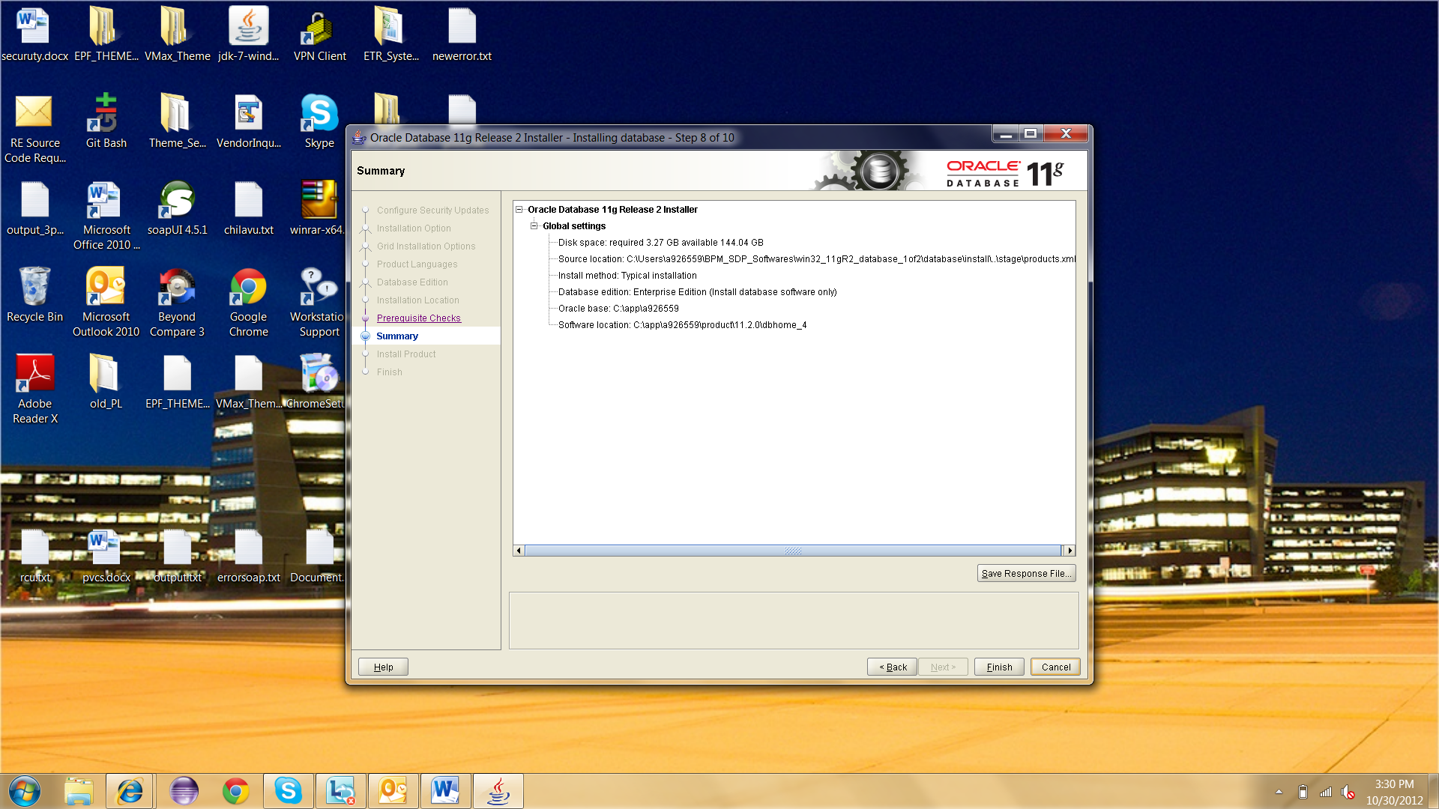

1. Once installation is done successfully click ‘Finish’.

### Installing Oracle WebLogic Server

1. Download the files required for installation of WebLogic Server to your machine.
2. Run the installer wls1036_win32.exe.
3. Click ‘Next’.

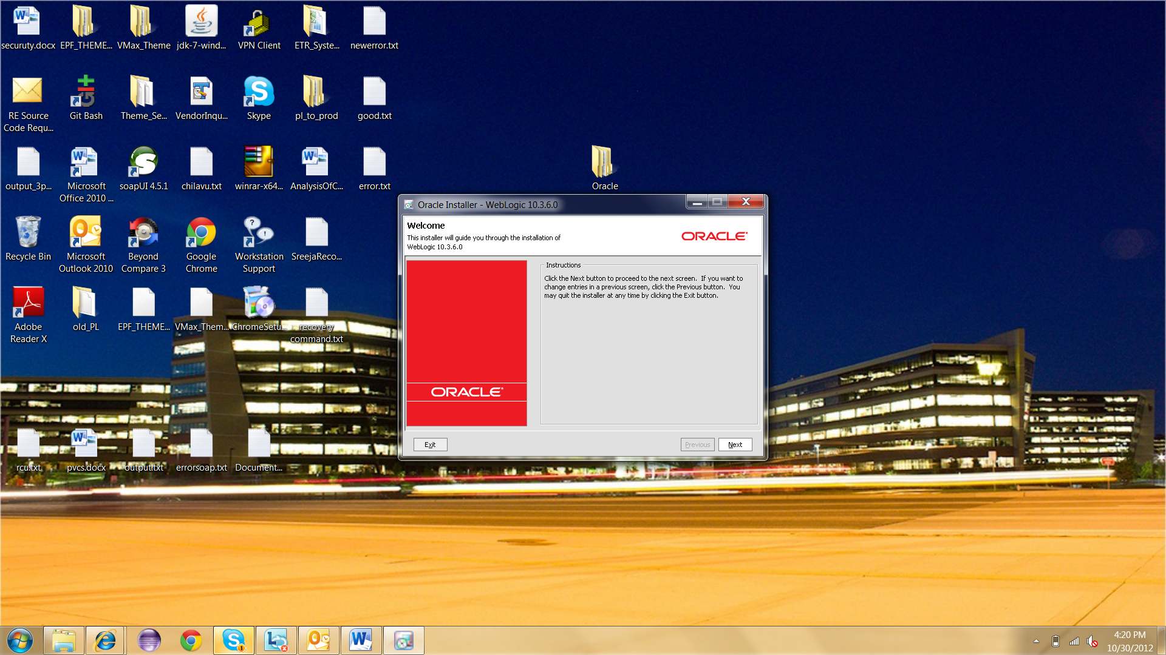

1. In the Choose Middleware Home Directory window, create a new Middleware Home. Enter or browse to the directory in which you would like to install both WebLogic and SOA. You can also use the default one ‘C:\Oracle\Middleware’.

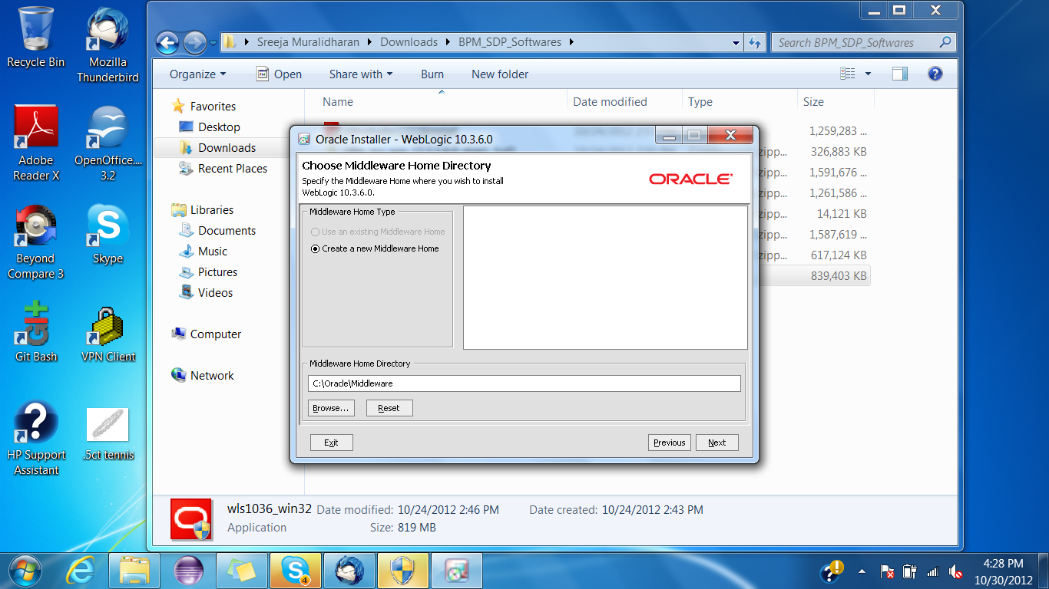

1. In the next screen, enter your email address to receive security alerts or deselect the checkbox and decline - whichever you prefer. Click ‘Next’.

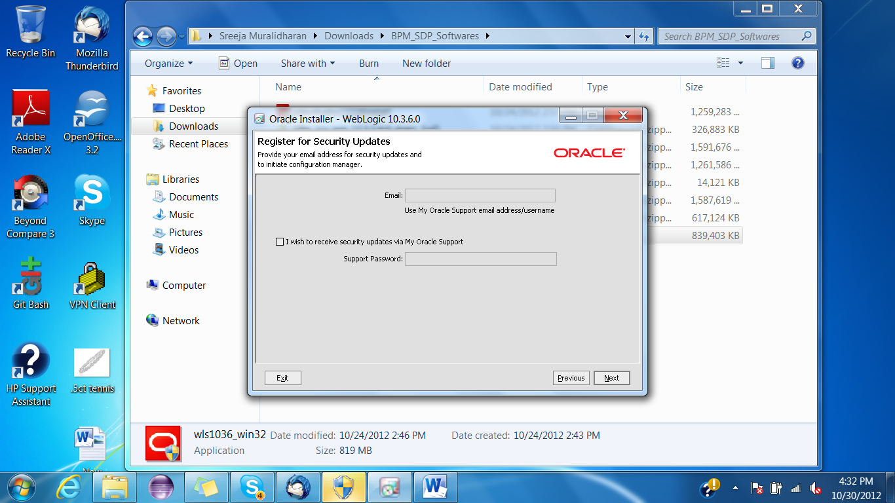

1. In the next screen, select radio button ‘Typical’ and click ‘Next’.

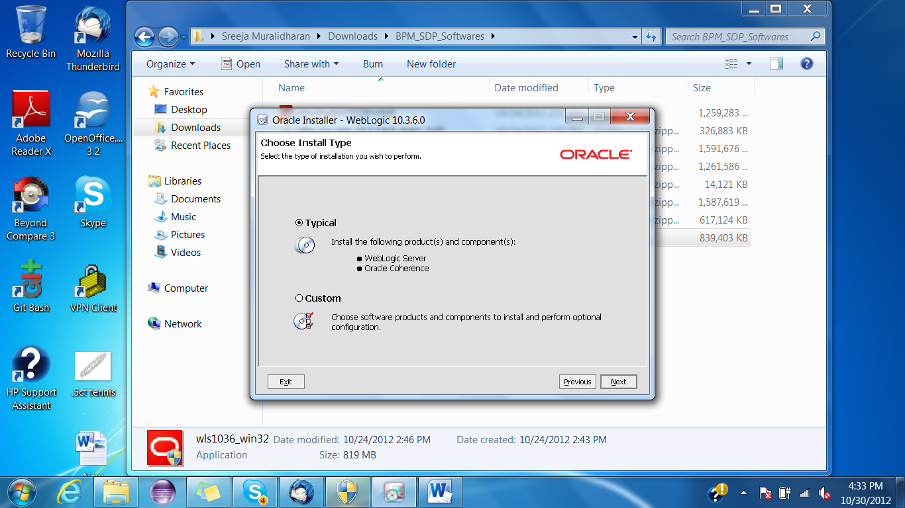

1. Click ‘Next’.

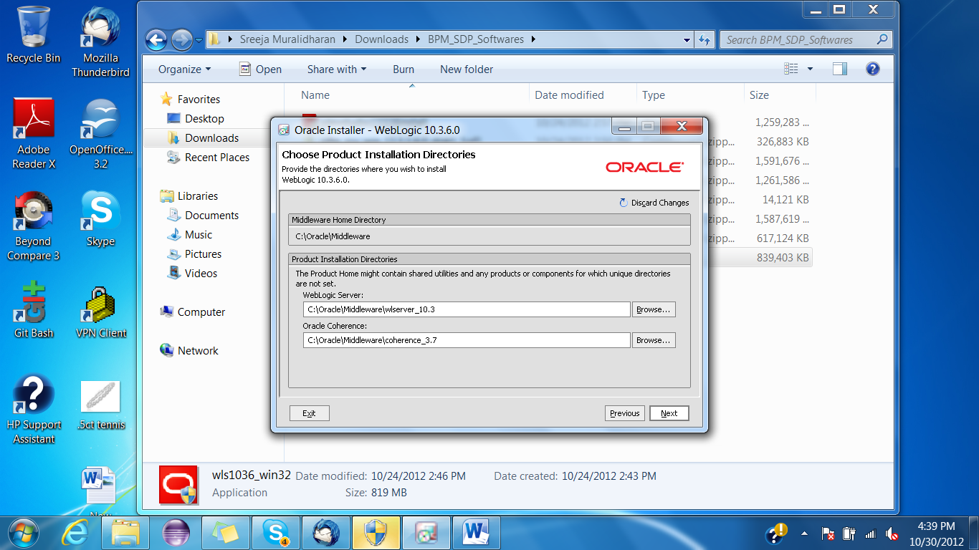

1. Click ‘Next’.

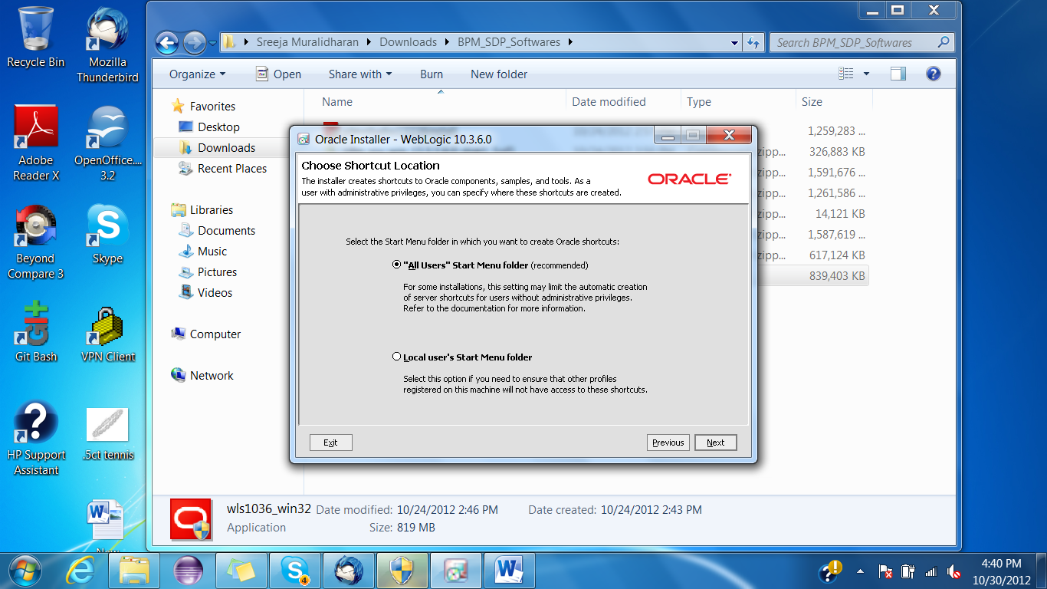

1. Click ‘Next’.

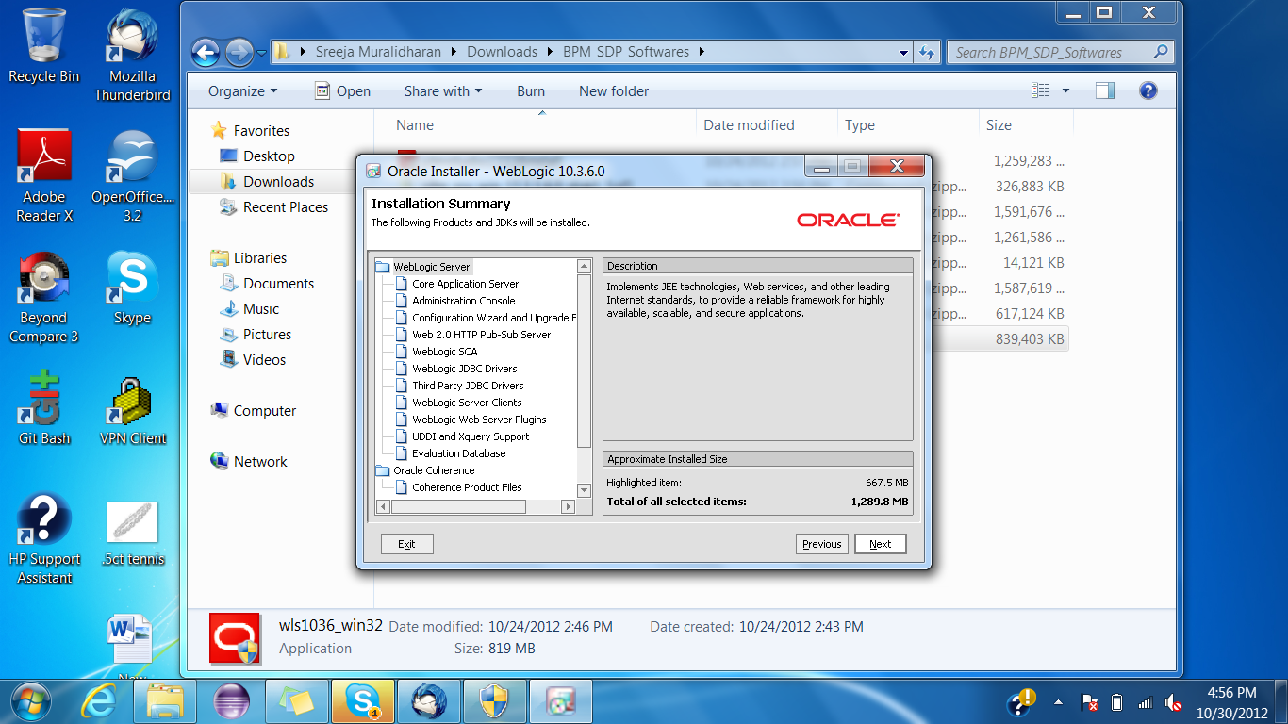

1. Once the server is installed click ‘Done’.

### Creating a Database

1. Open ‘Database Configuration Assistant’ from Start->All Programs->Oracle-OraDb11g_home1->Configuration and Migration Tools.
2. Click ‘Next’.

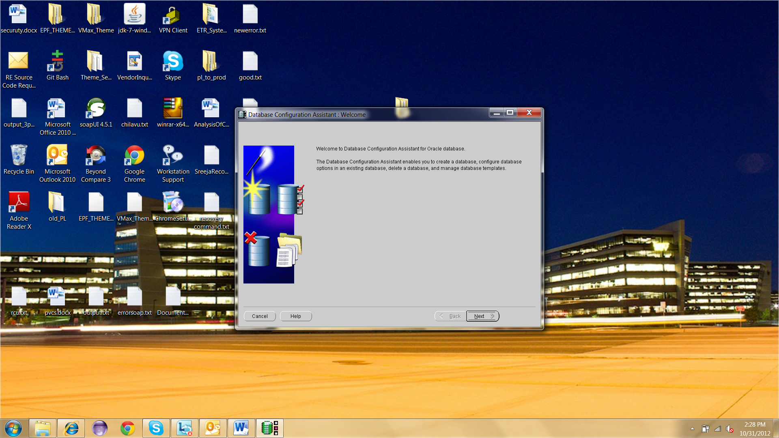

1. Select ‘Create a database’ and click ‘Next’.

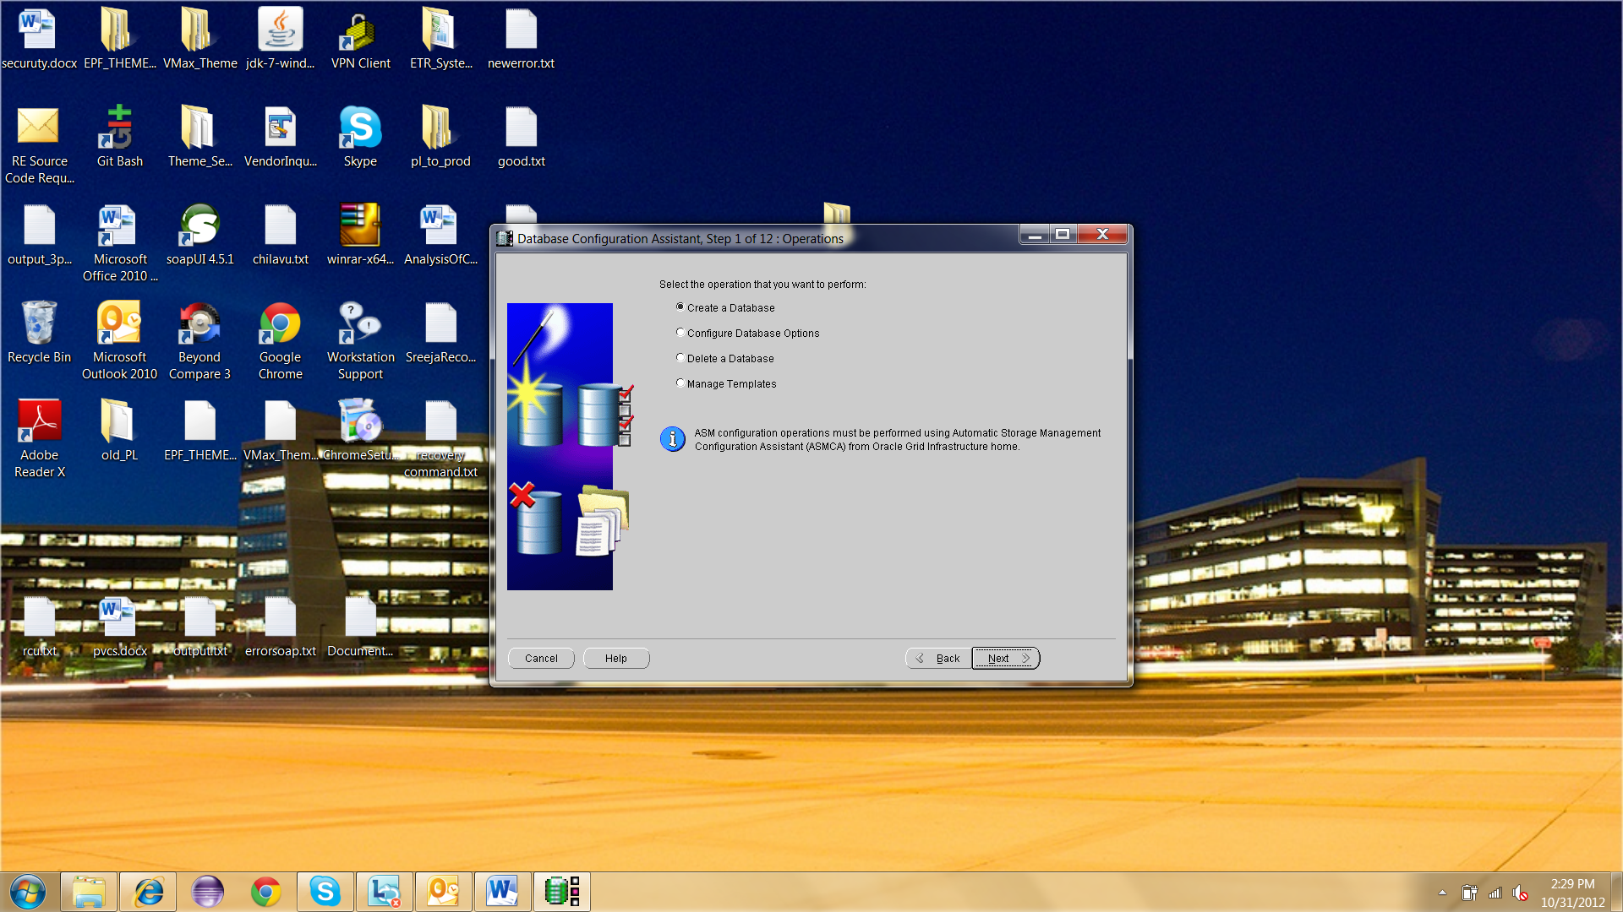

1. Click ‘Next’.

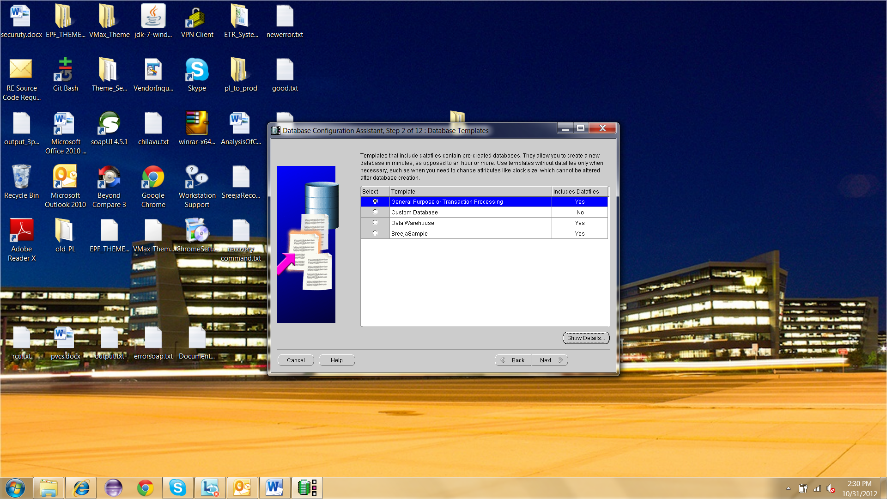

1. Enter the name for your database.

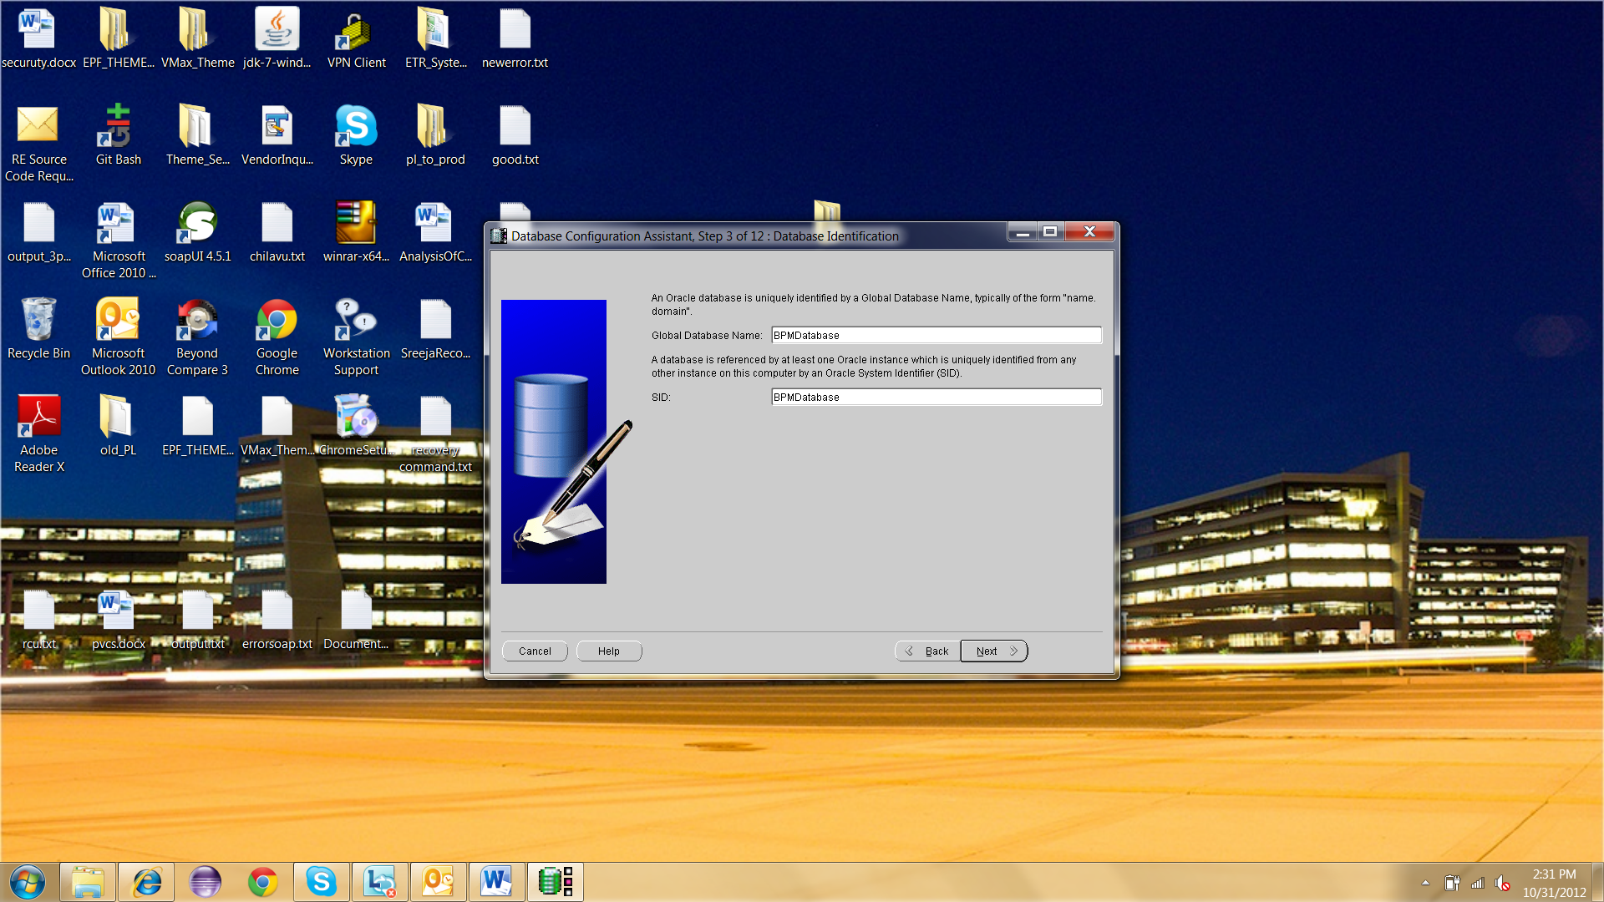

1. Click ‘Next’.

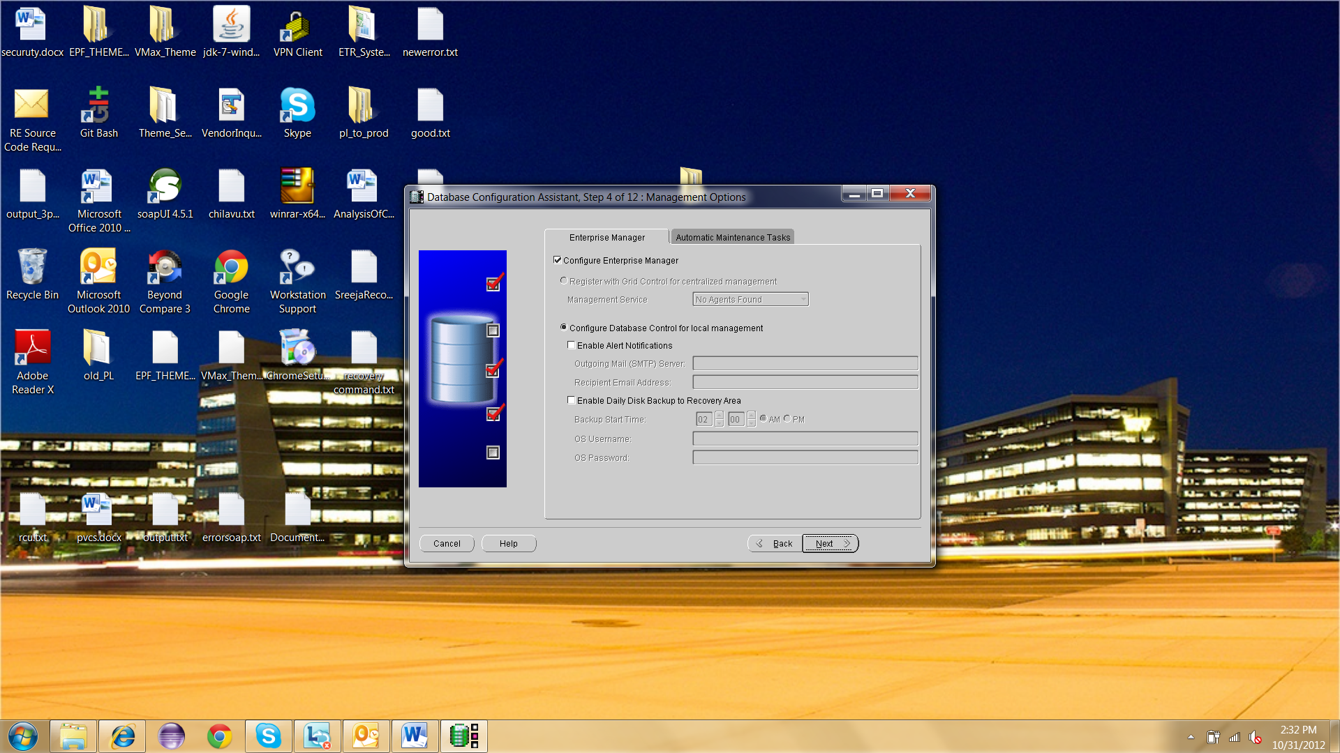

1. Select ‘Use same password for all accounts’. Enter the password. Click ‘Next’.

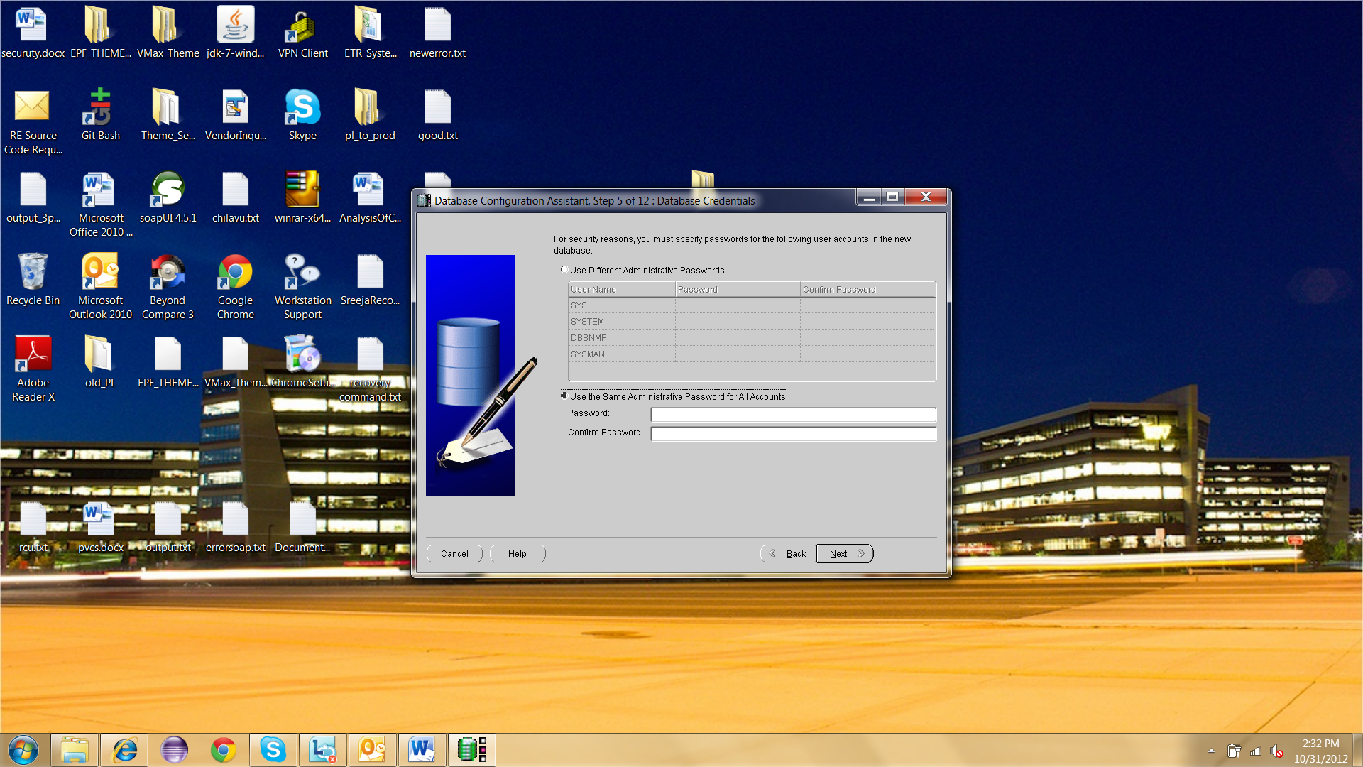

1. Click ‘Next’.

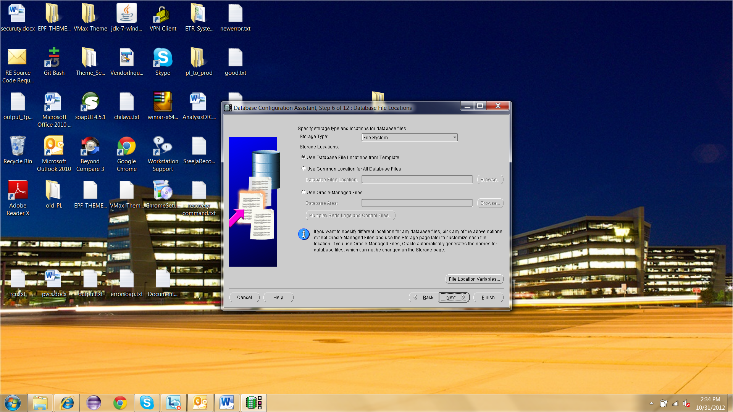

1. Click ‘Next’.

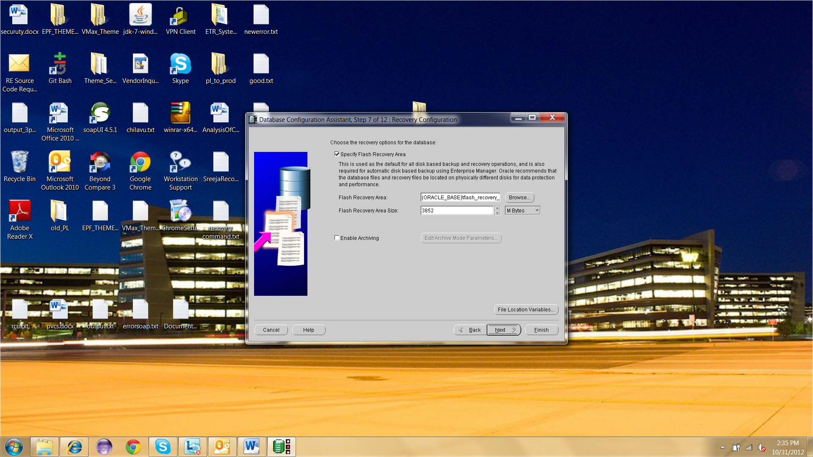

1. Click ‘Next’.

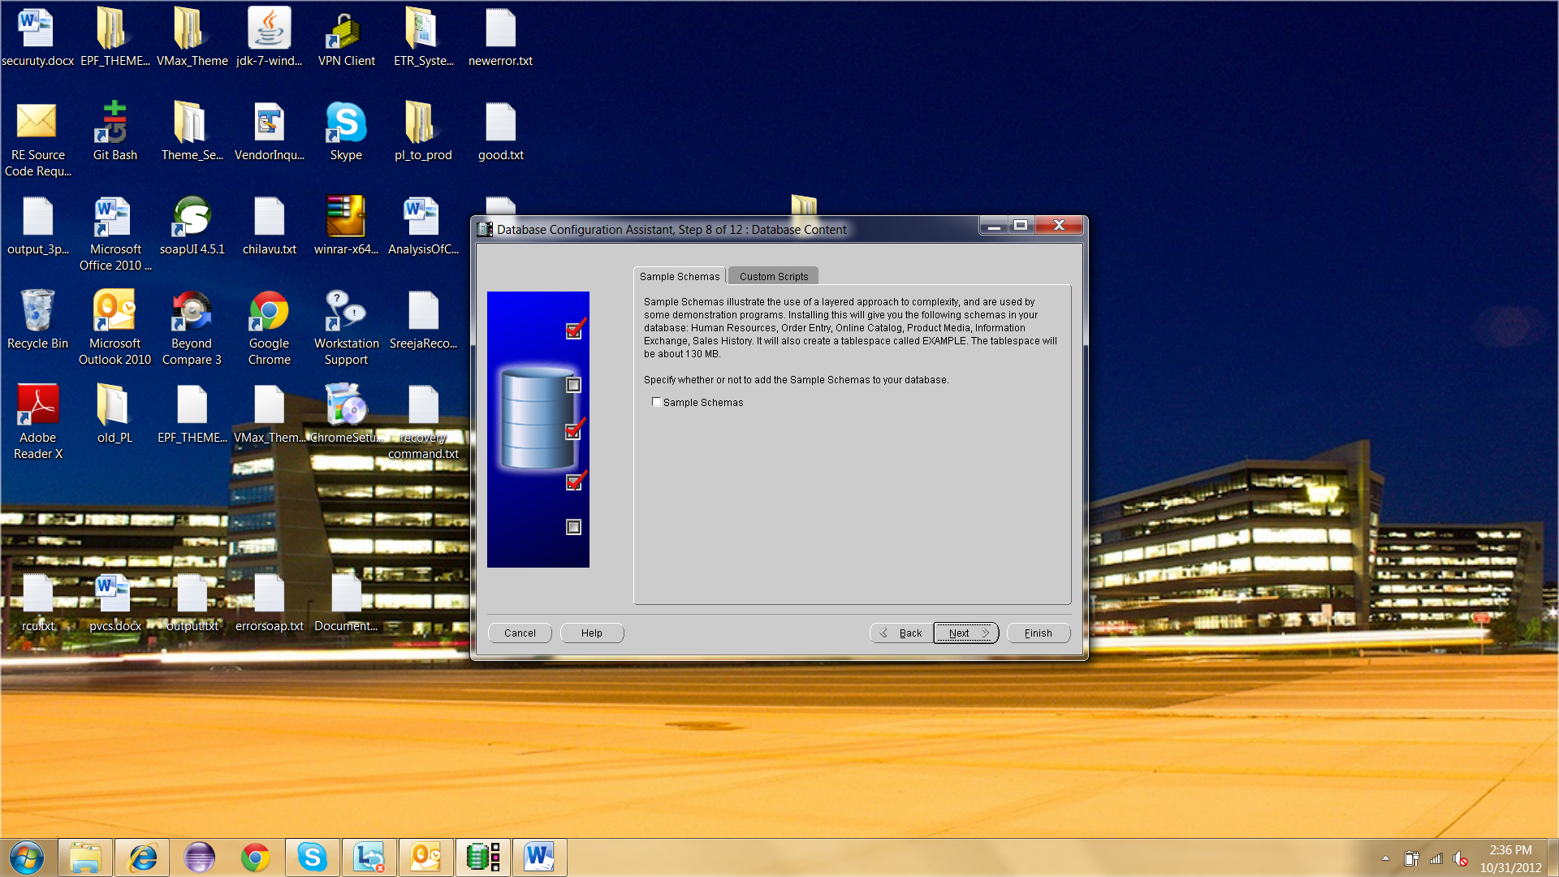

1. Click on tab ‘Character Set’ and select ‘Use Unicode’ .Click ‘Next’ to proceed.

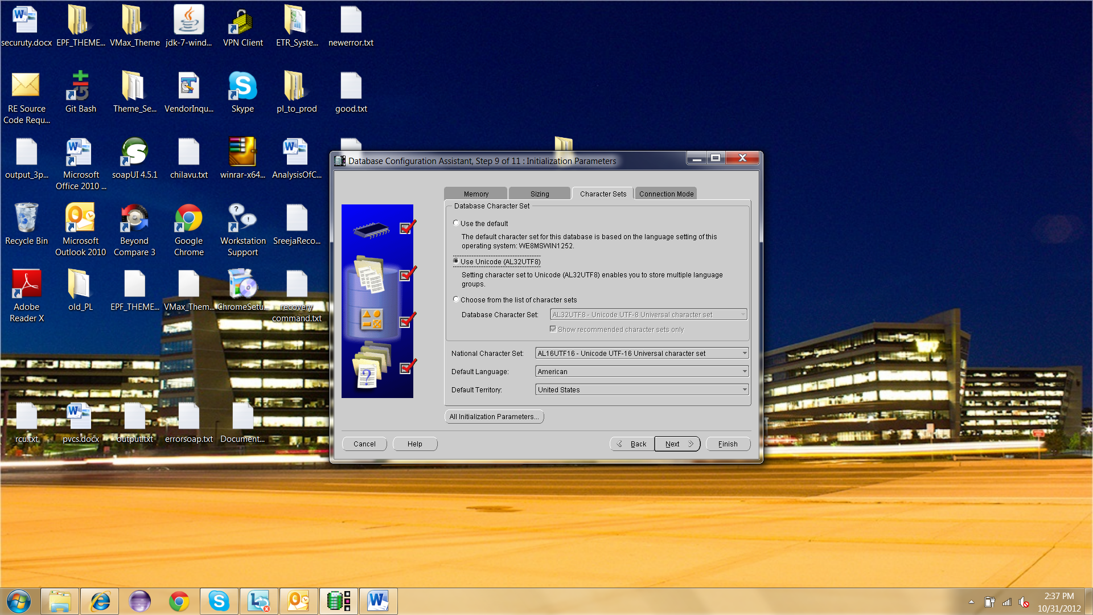

1. Click on ‘Finish’ to create the database successfully.

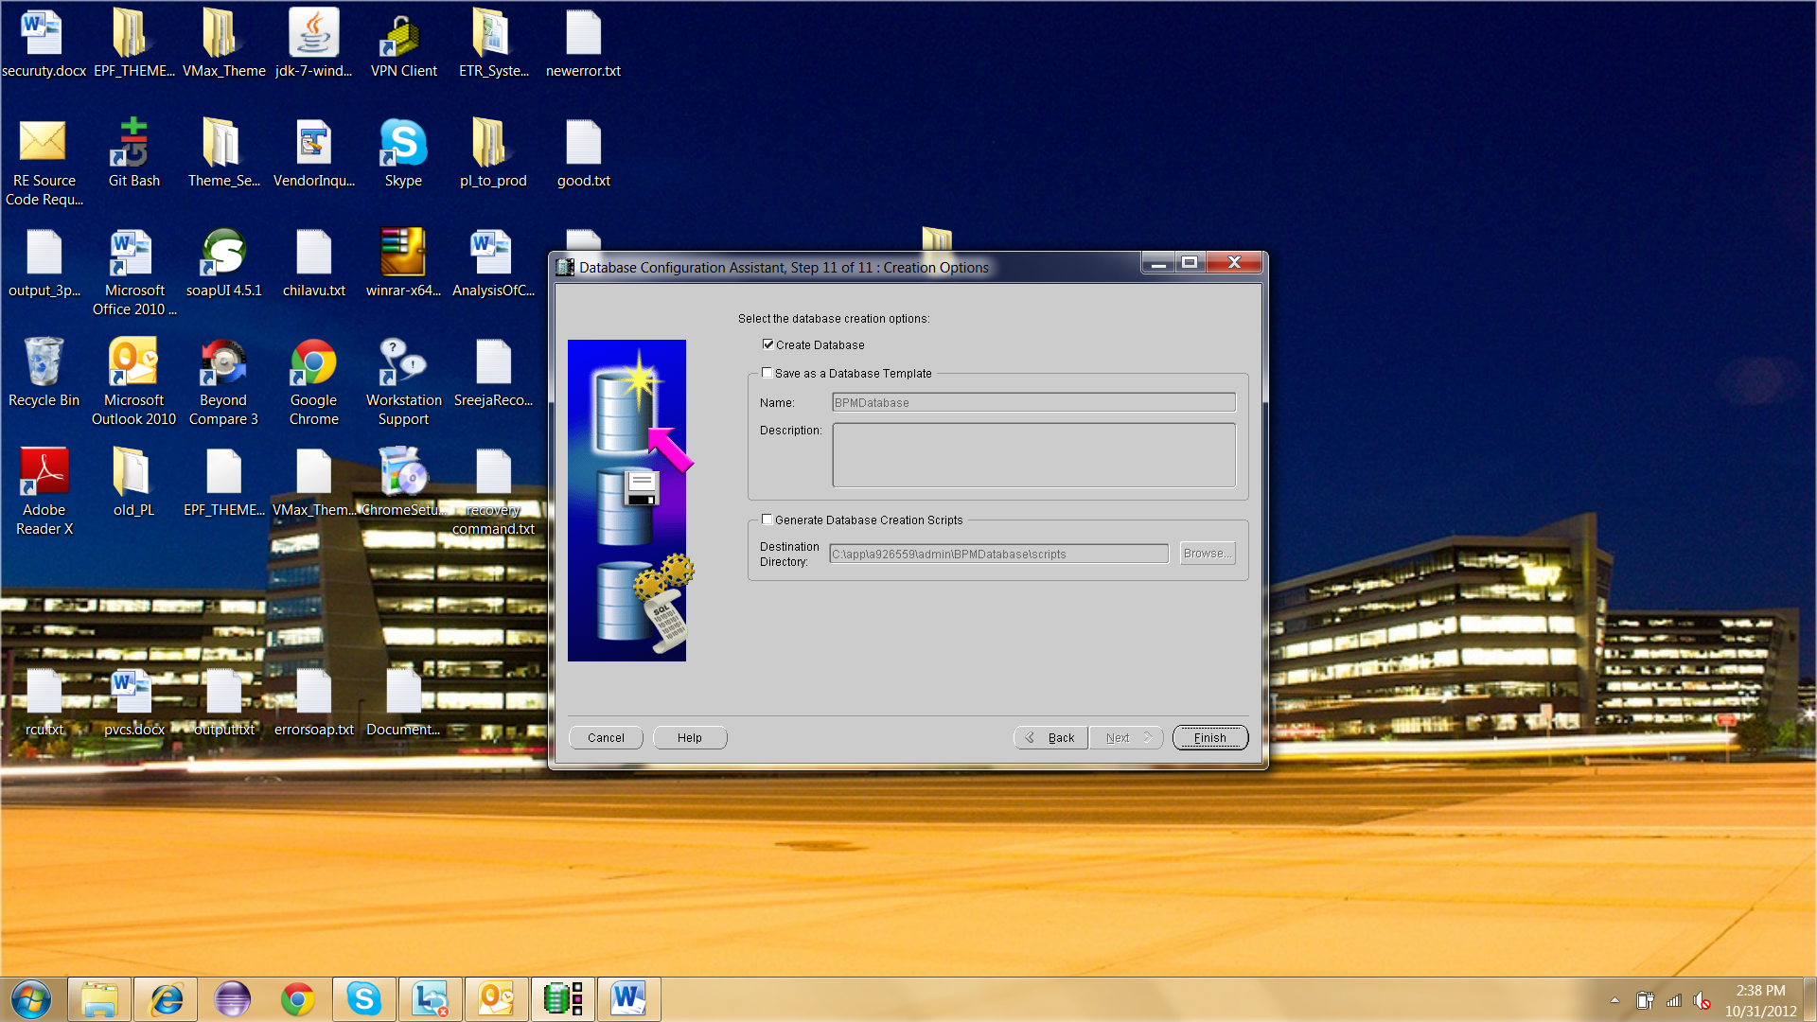

### Installing Repository Creation Utility

1. Extract the downloaded RCU files and run rcu.bat from ofm_rcu_win_11.1.1.6.0_disk1_1of1\rcuHome\BIN folder.
2. Click ‘Next’.

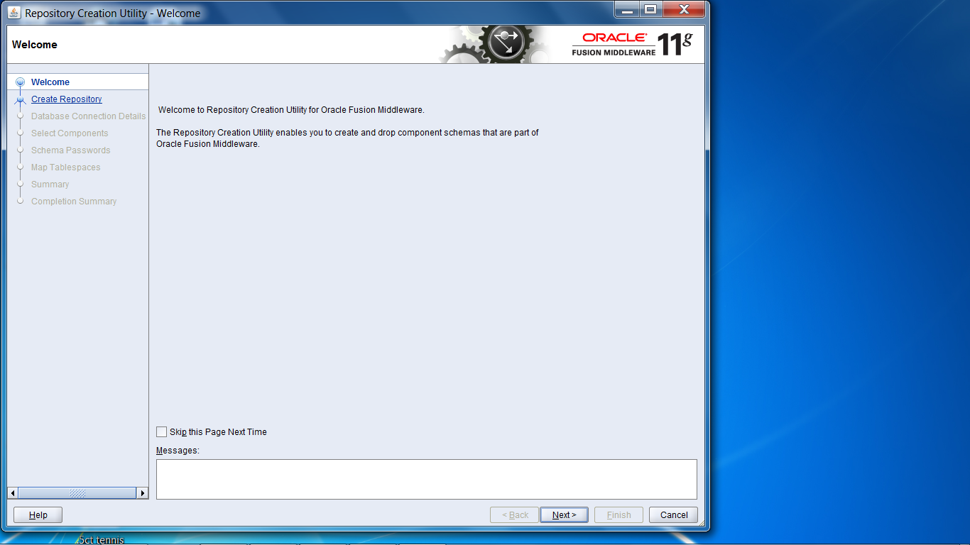

1. Click ‘Next’.

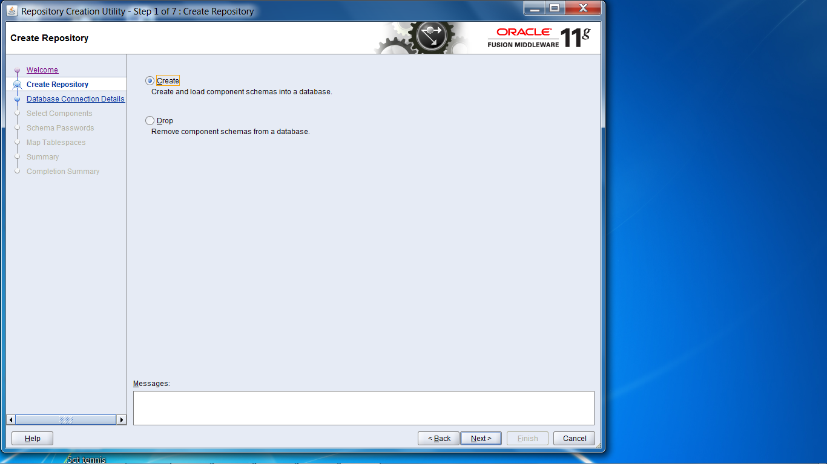

1. Enter the the fields with the correct information. The port 1521 is the default one. Click ‘Next’.

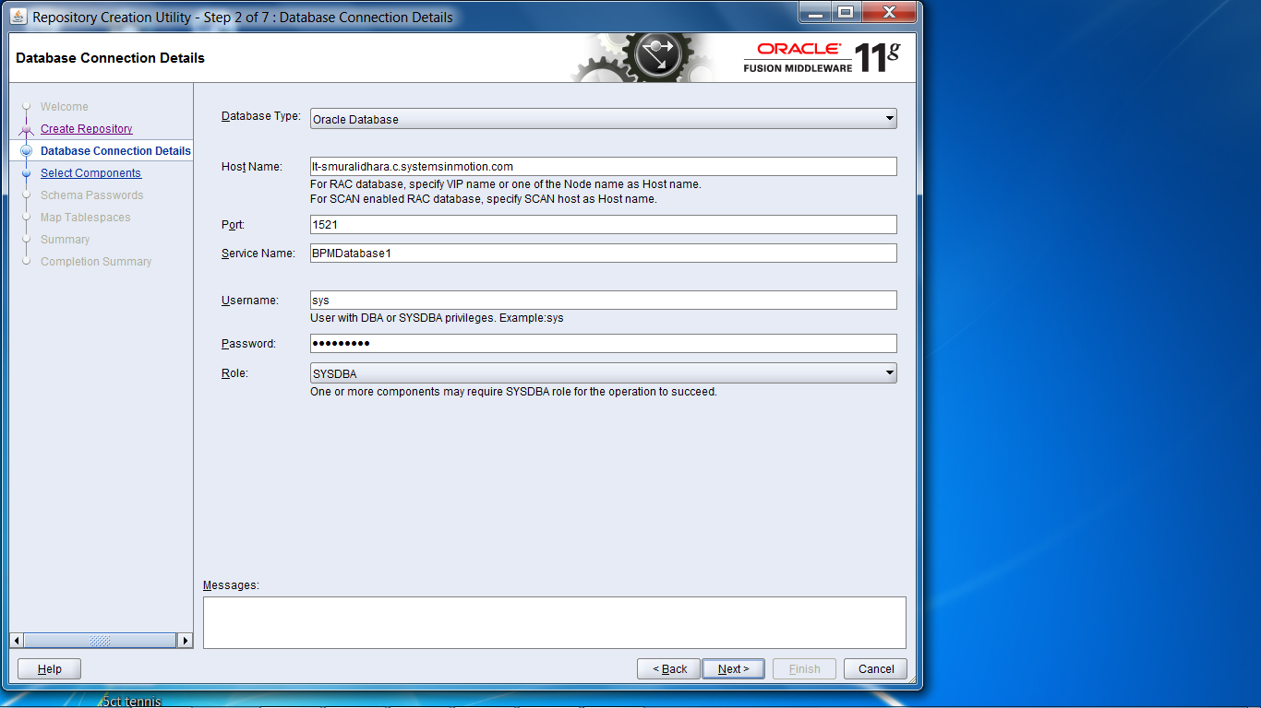

1. Click ‘OK’.

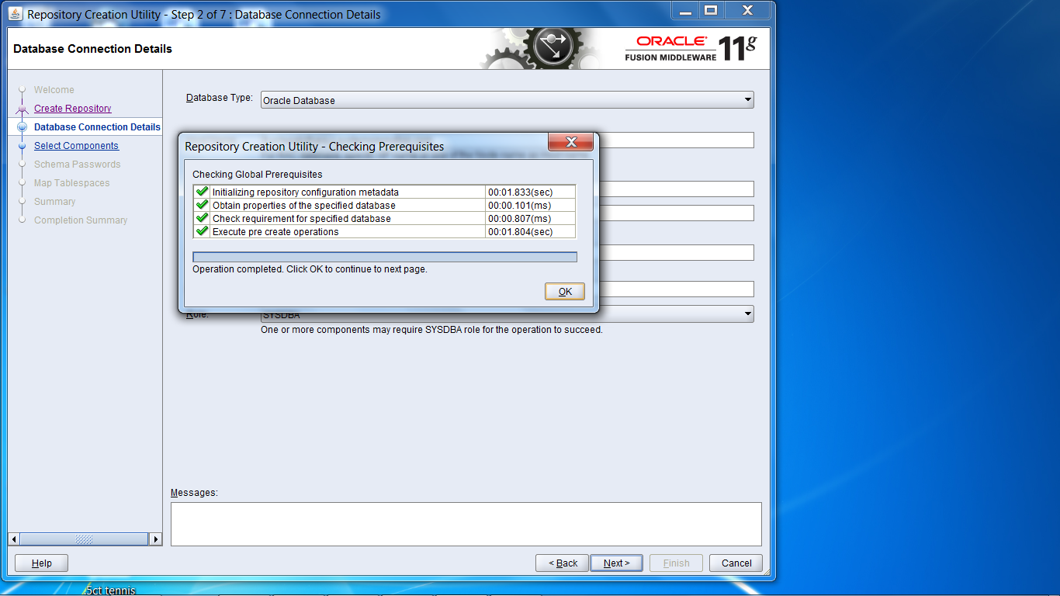

1. Select ‘SOA and BPM Infrastructure’. Click ‘Next’.

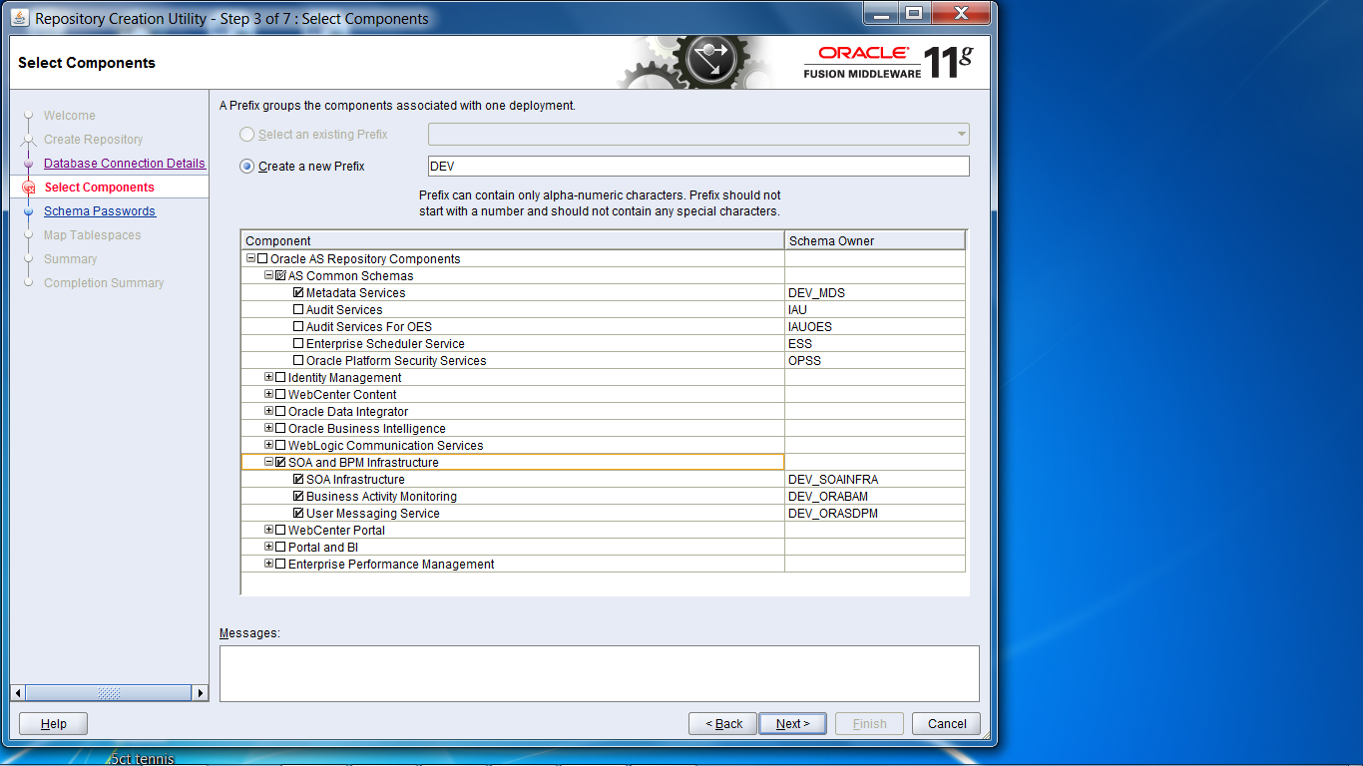

1. Click ‘OK’.

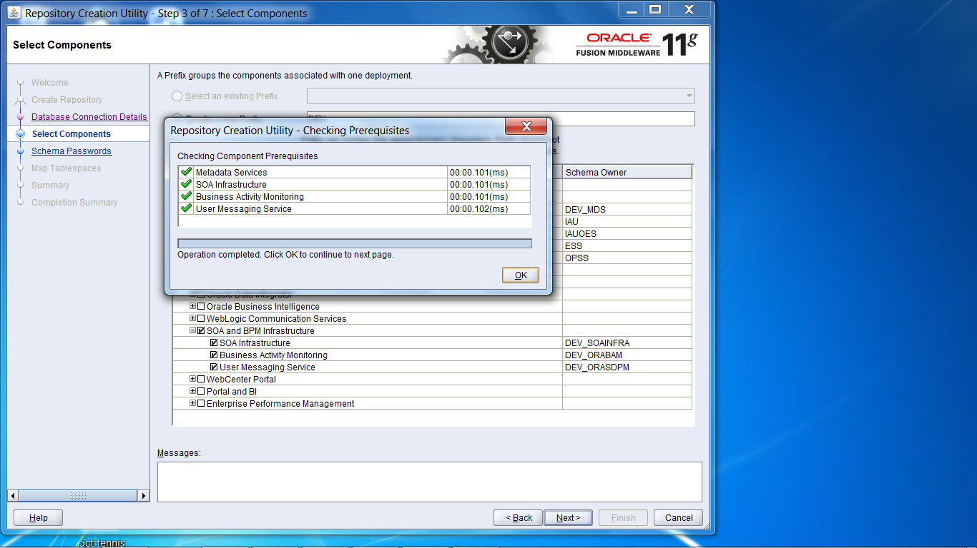

1. Enter the password and click ‘Next’.

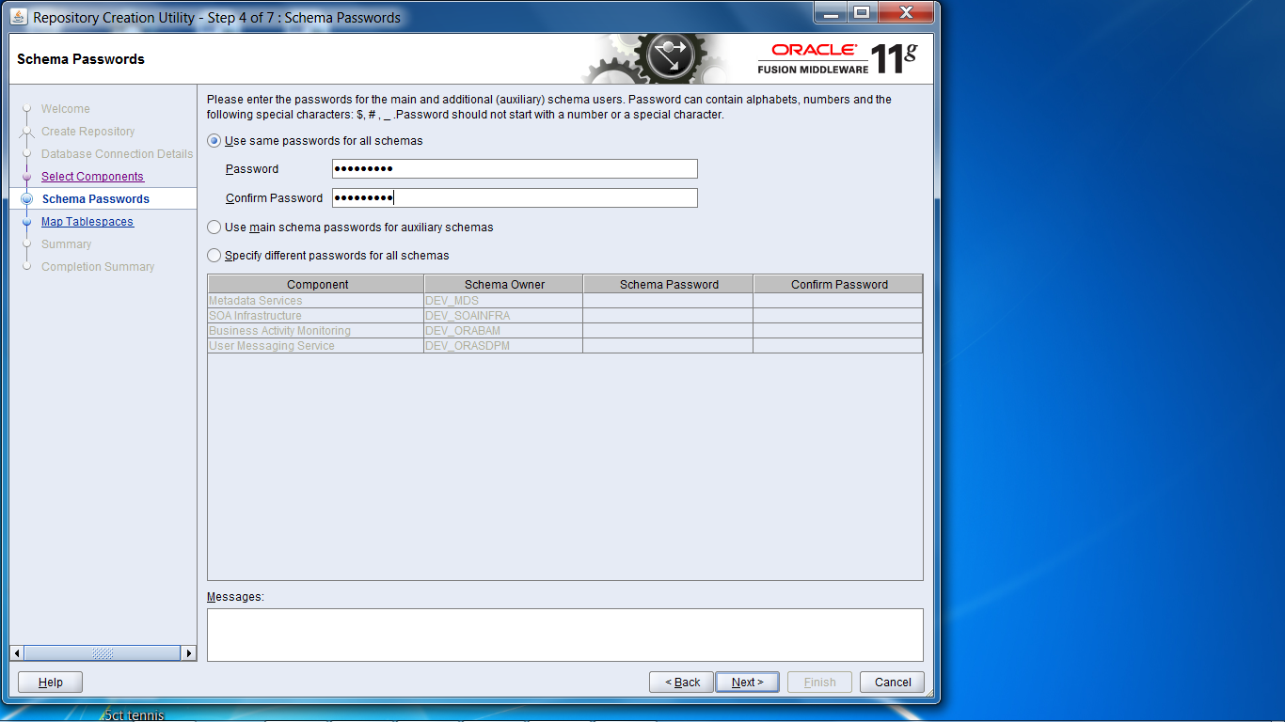

1. Click ‘Next’.

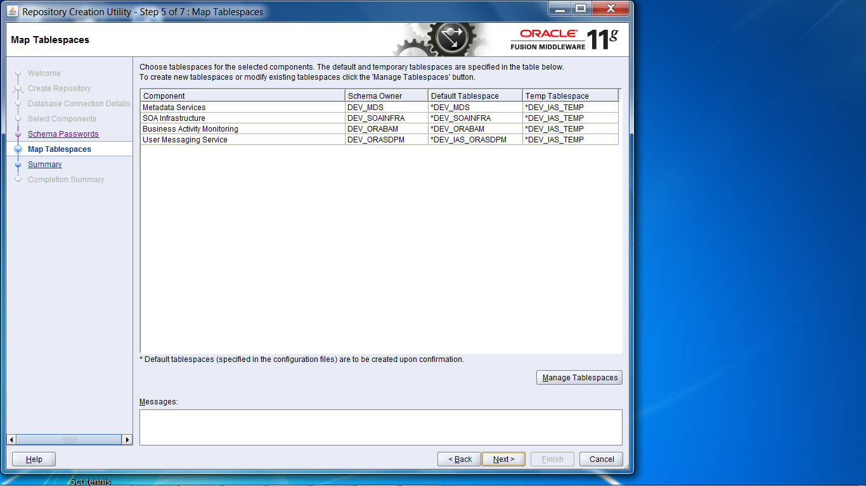

1. Click ‘OK’.

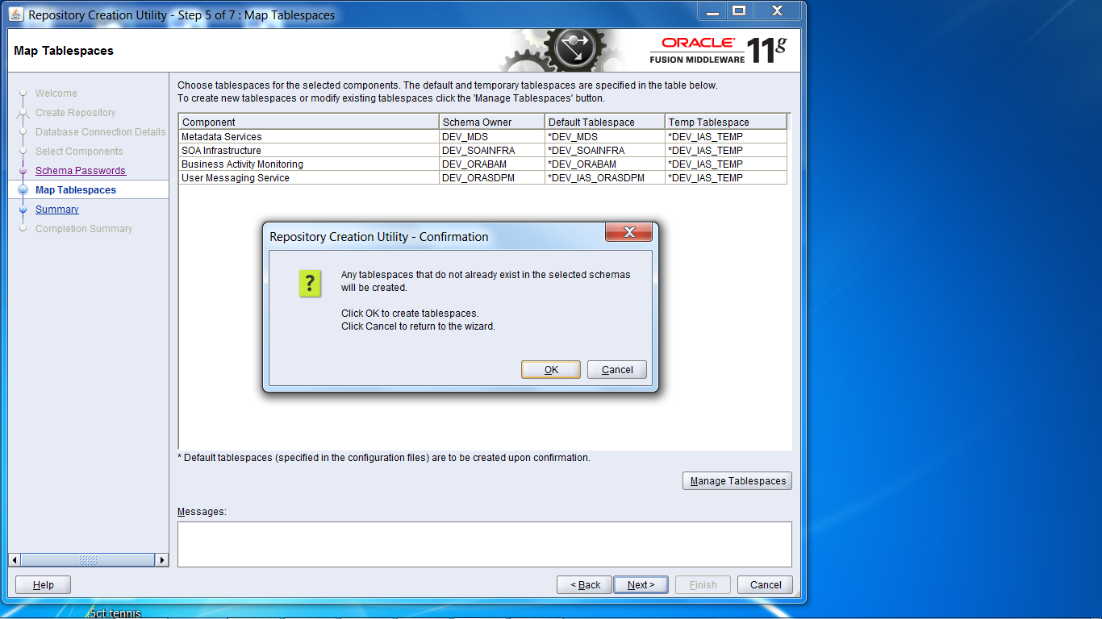

1. Click ‘OK’.

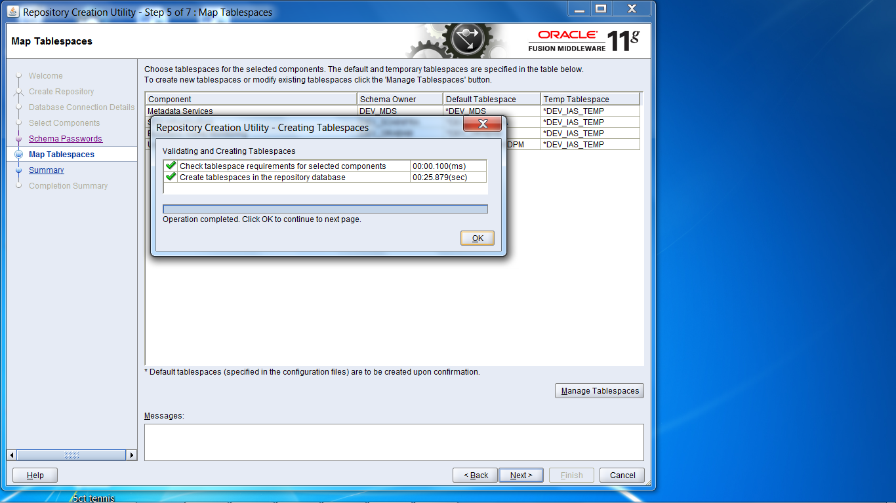

1. Click ‘Create’.

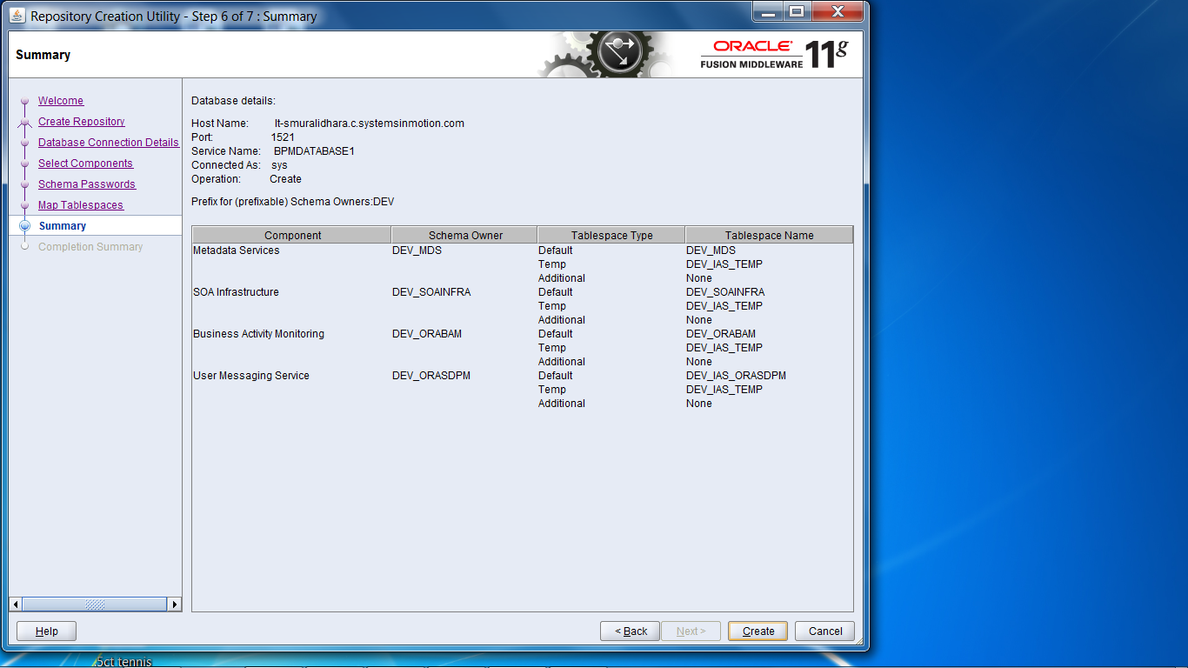

1. Click ‘Close’.

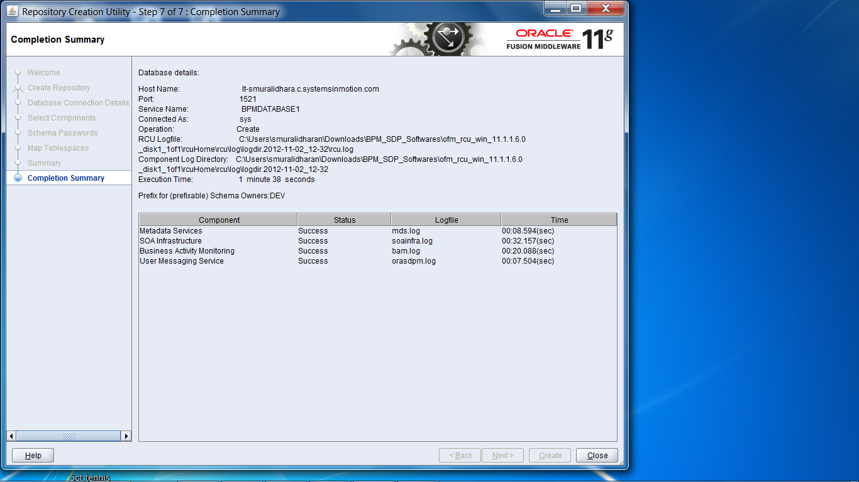

### Installing JDeveloper 11g

1. Start the downloaded application installation. Click ‘Next’.

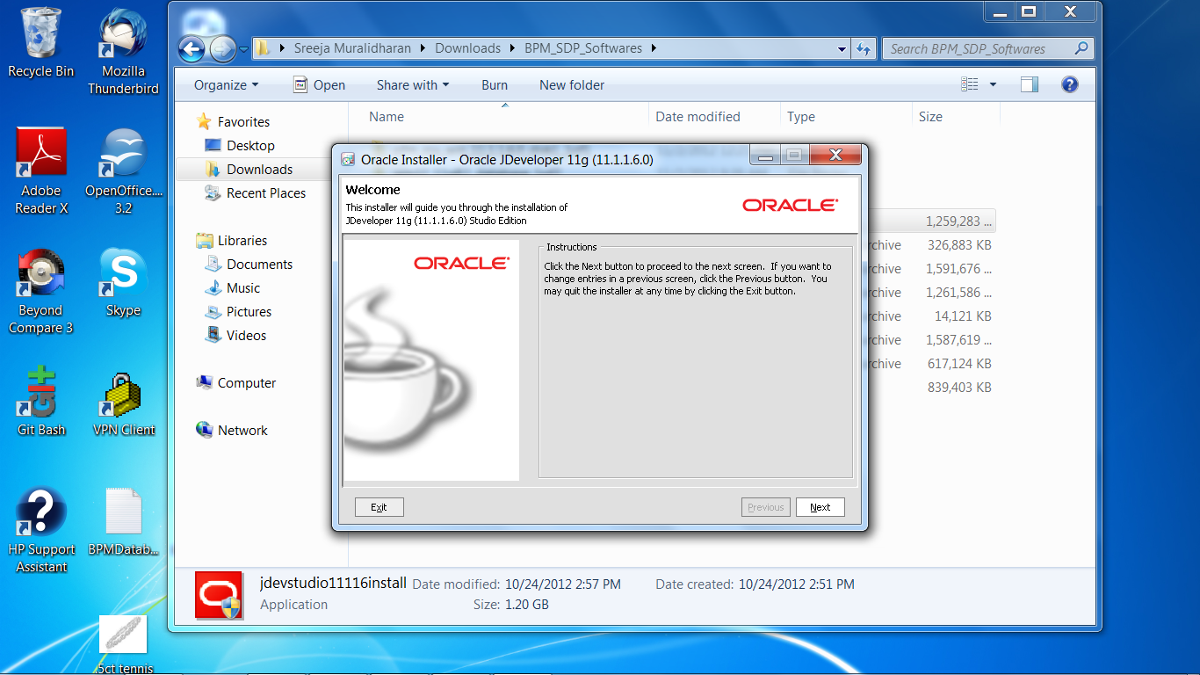

1. Select the radio button ‘Create a new middleware home’. Click ‘Next’.

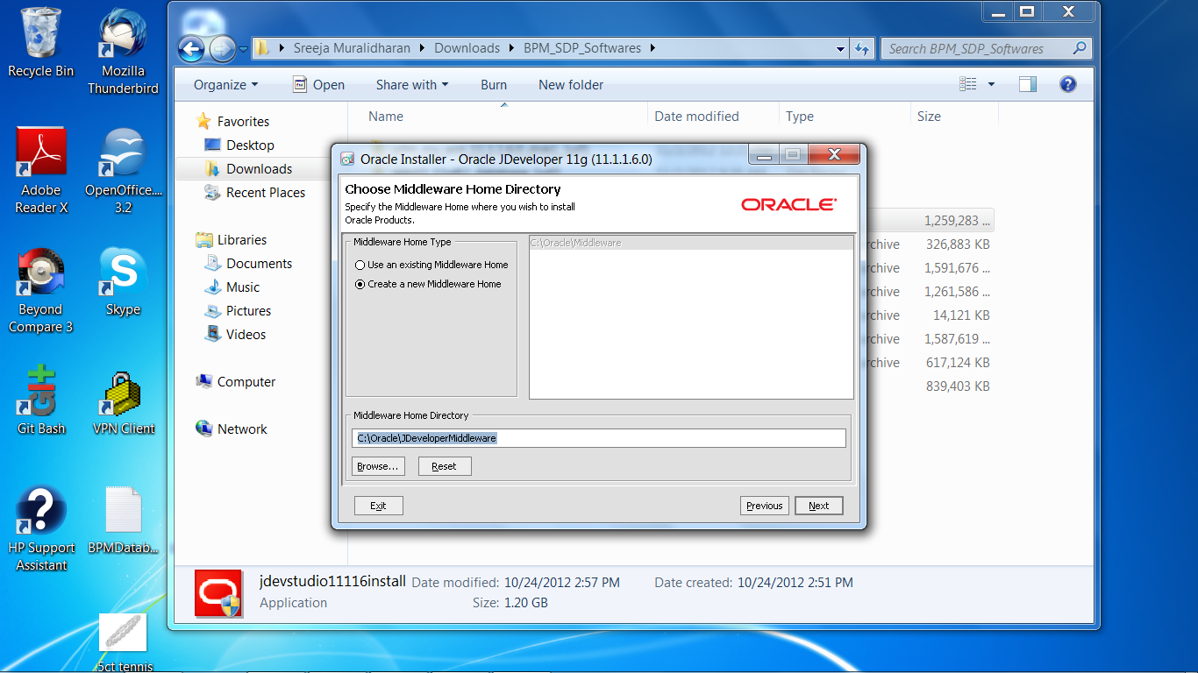

1. Click ‘Next’.

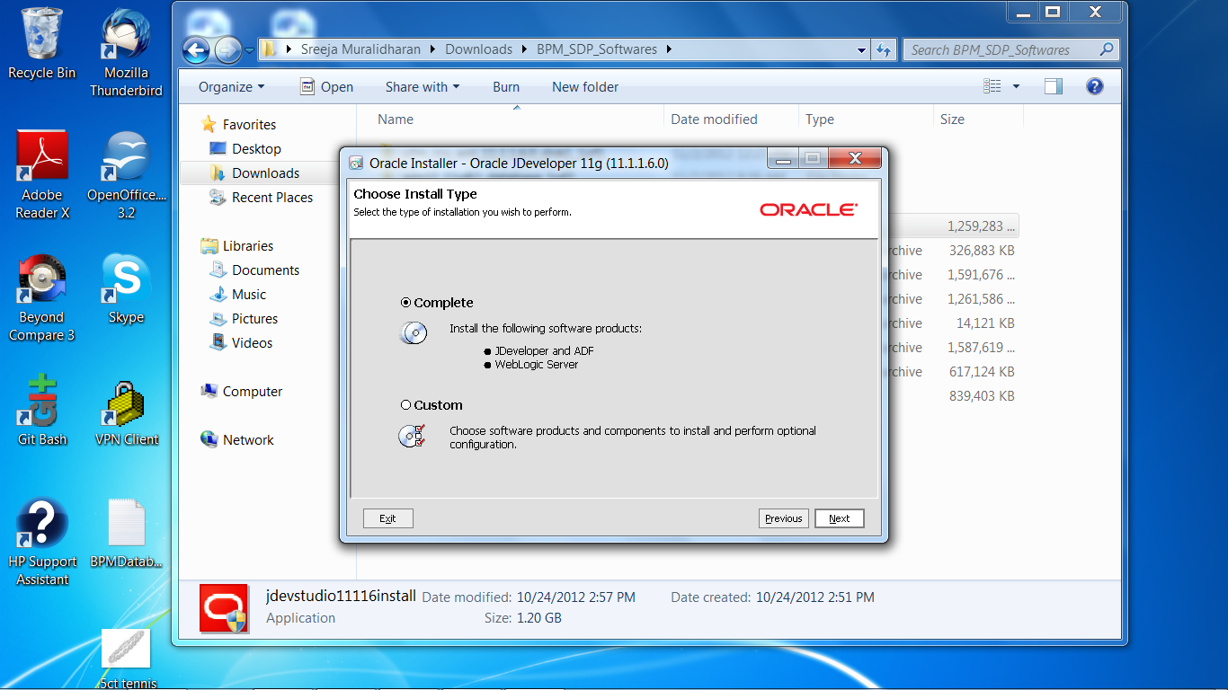

1. Click ‘Next’.

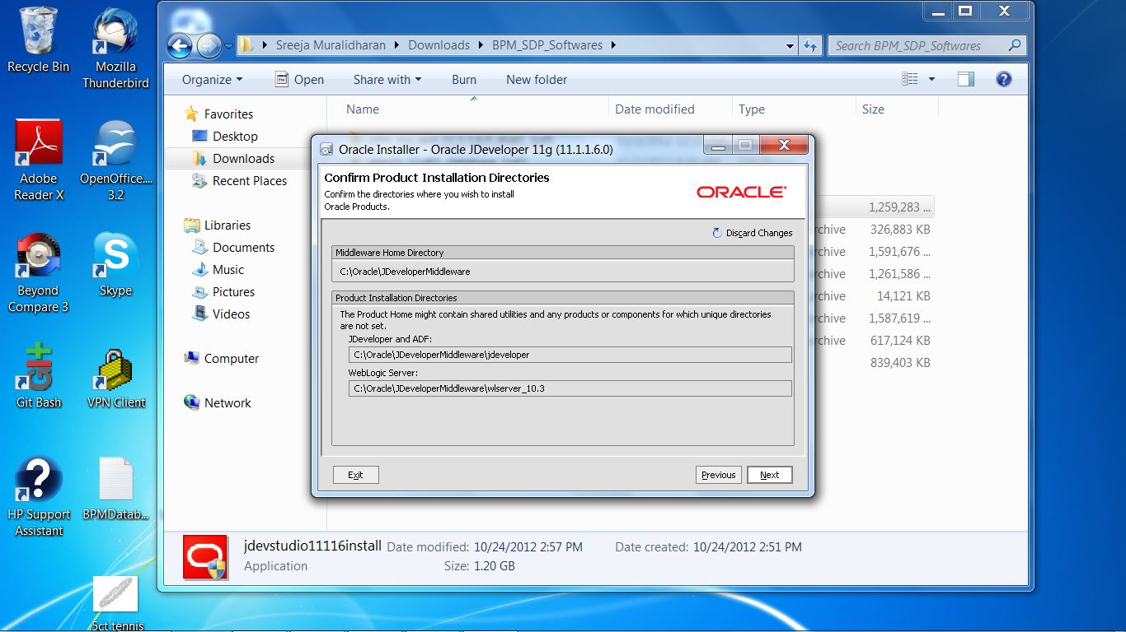

1. Click ‘Next’.

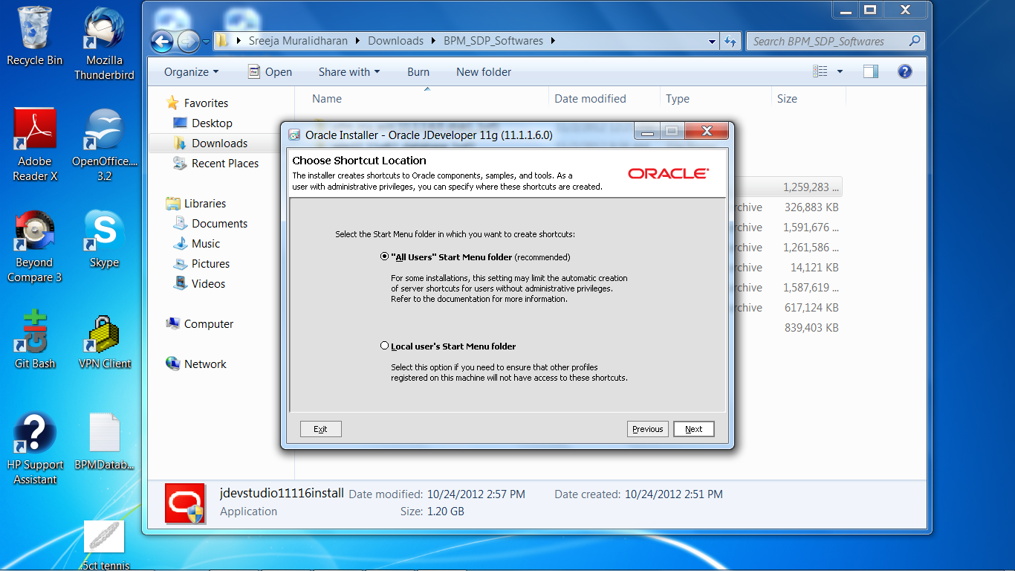

1. Click ‘Next’.

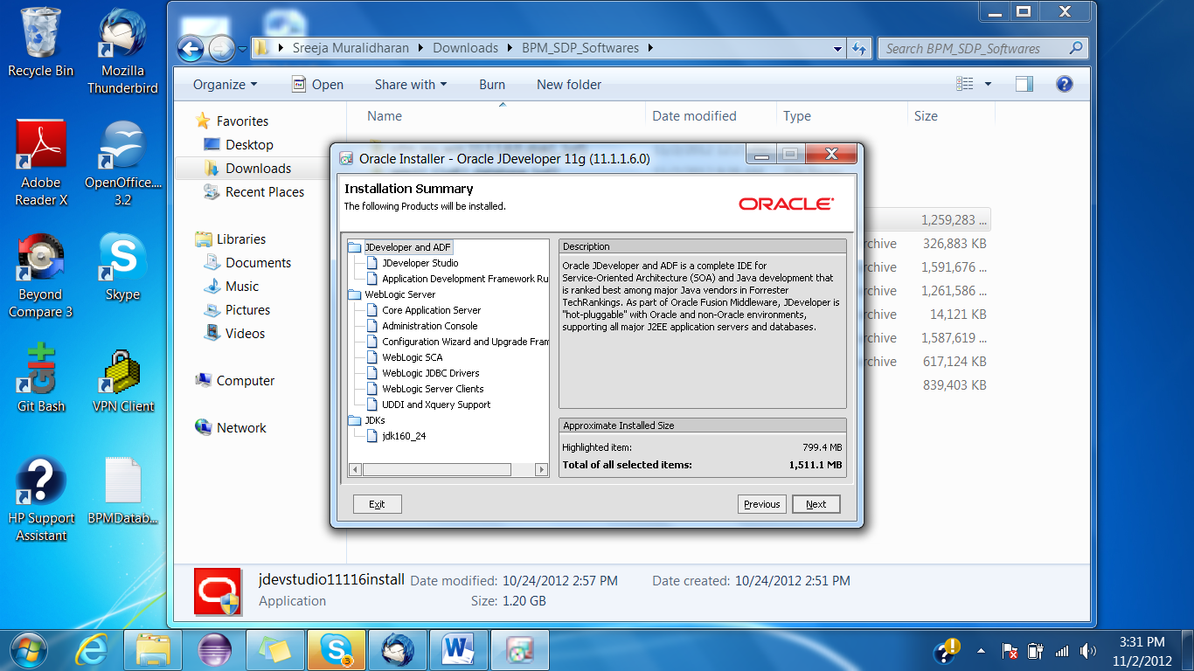

1. Click ‘Done’.

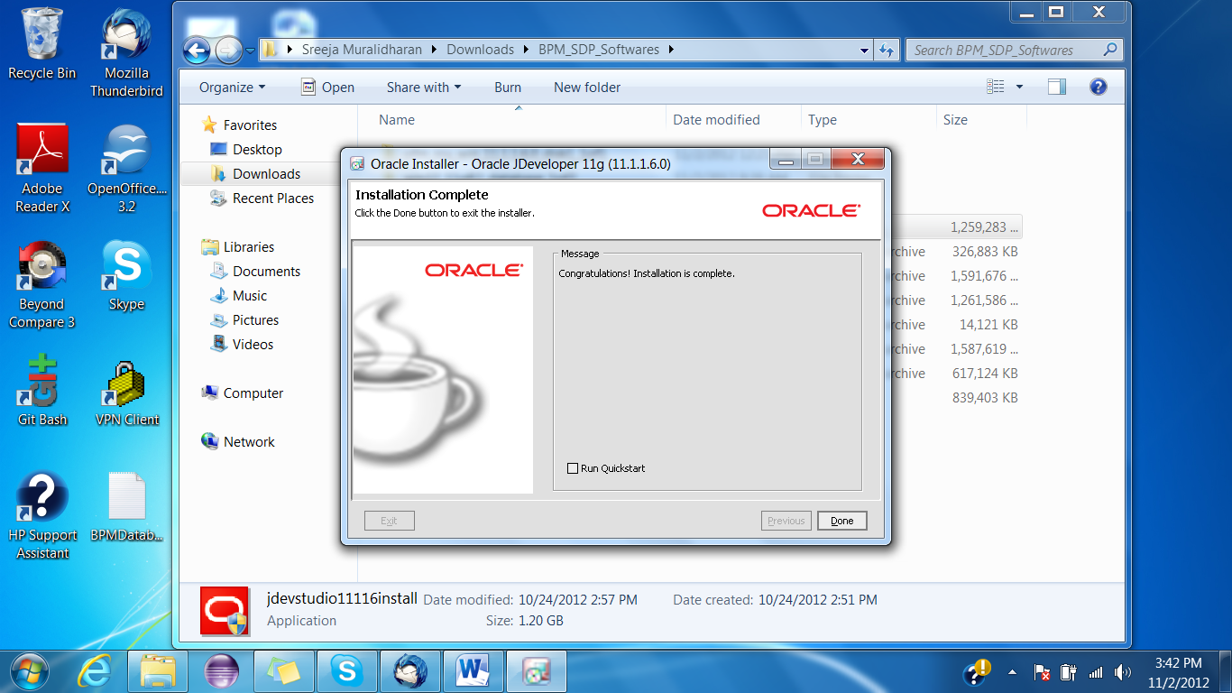

### Installing SOA Suite 11.1.1.6.0

1. Extraxt all the files from the downloaded zip of SOA suite.
2. Run the installer set up from the location ofm_soa_generic_11.1.1.6.0_disk1_1of2\Disk1\install\win32\setup .
3. The installation will prompt you to enter the jre location in your system.

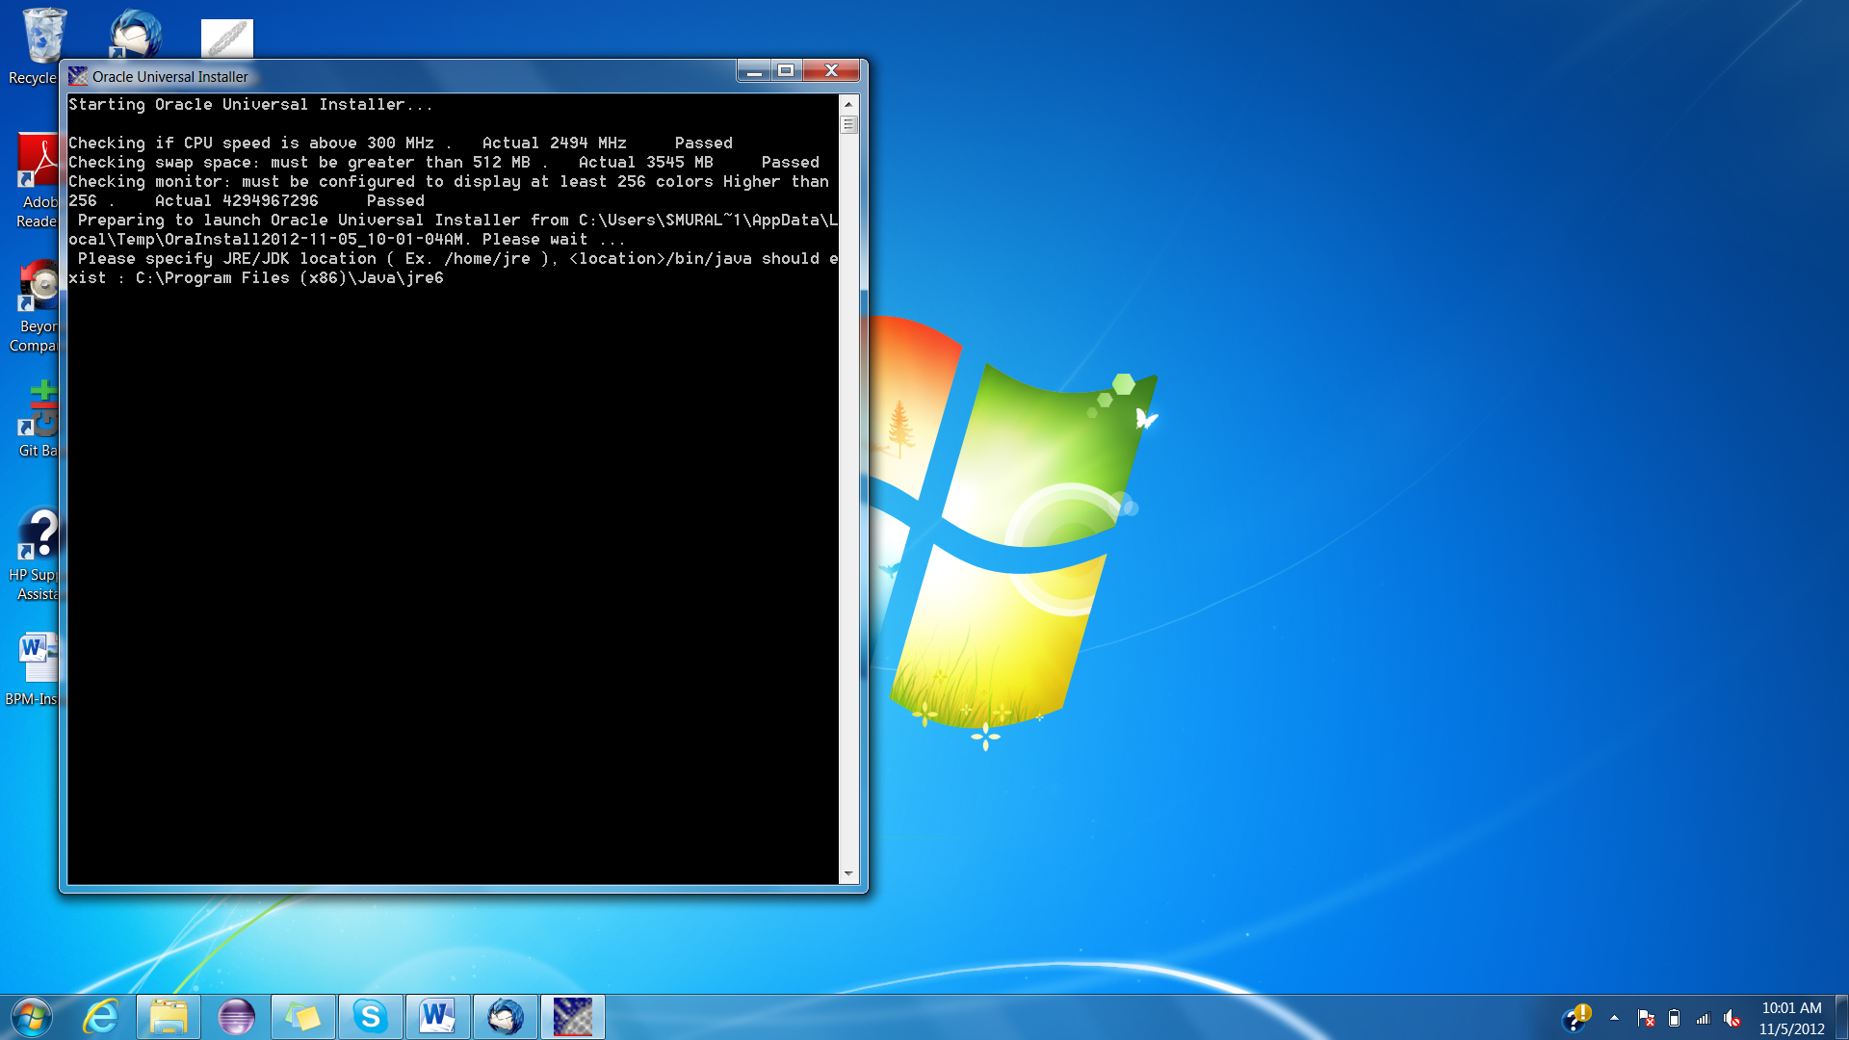

1. Click ‘Next’.

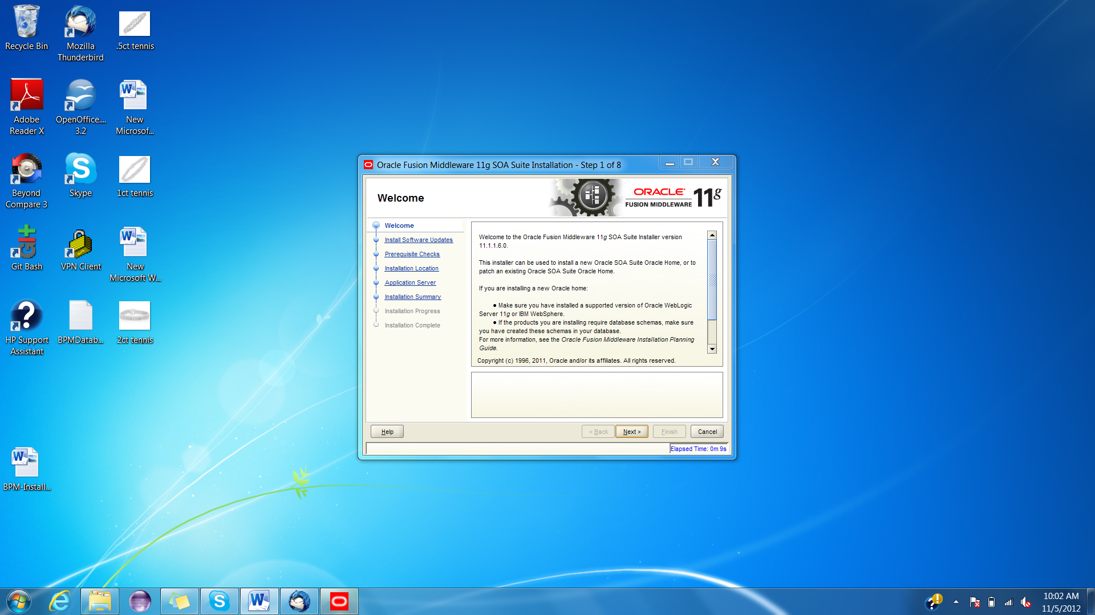

1. Click ‘Next’.

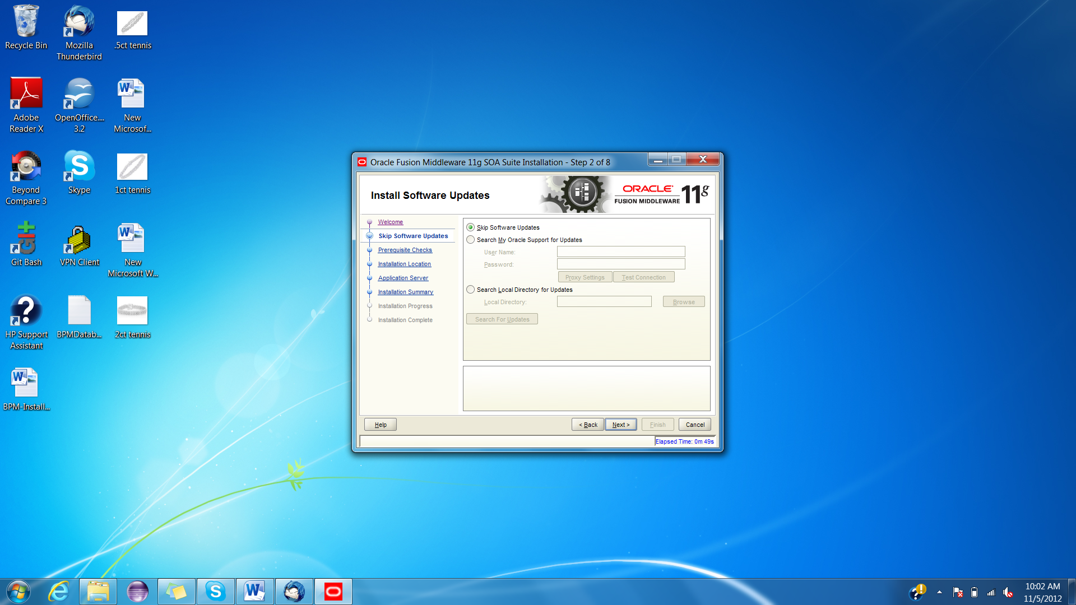

1. Click ‘Next’.

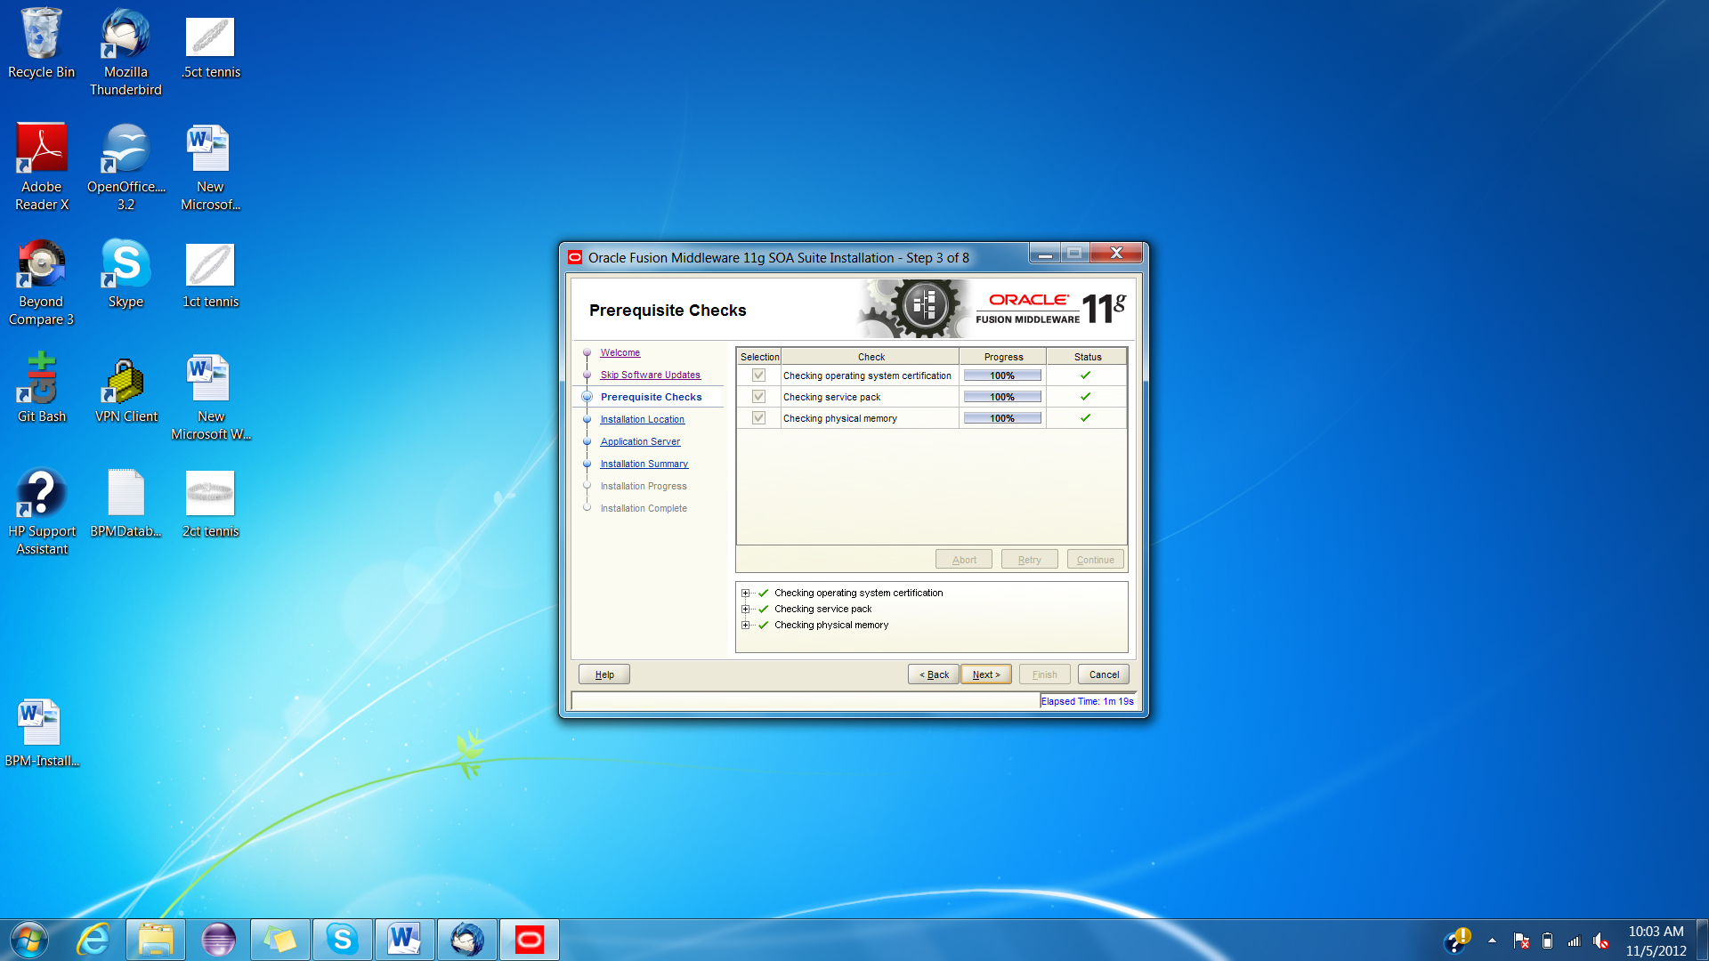

1. Click ‘Next’.

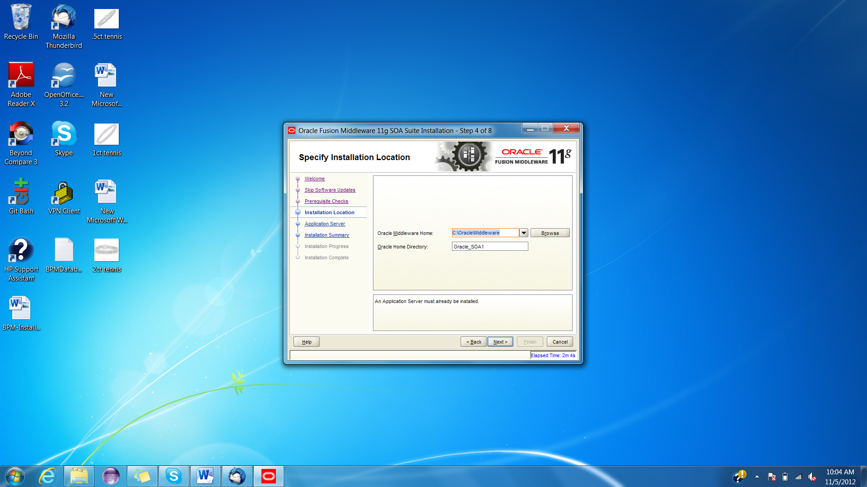

1. Click ‘Next’.

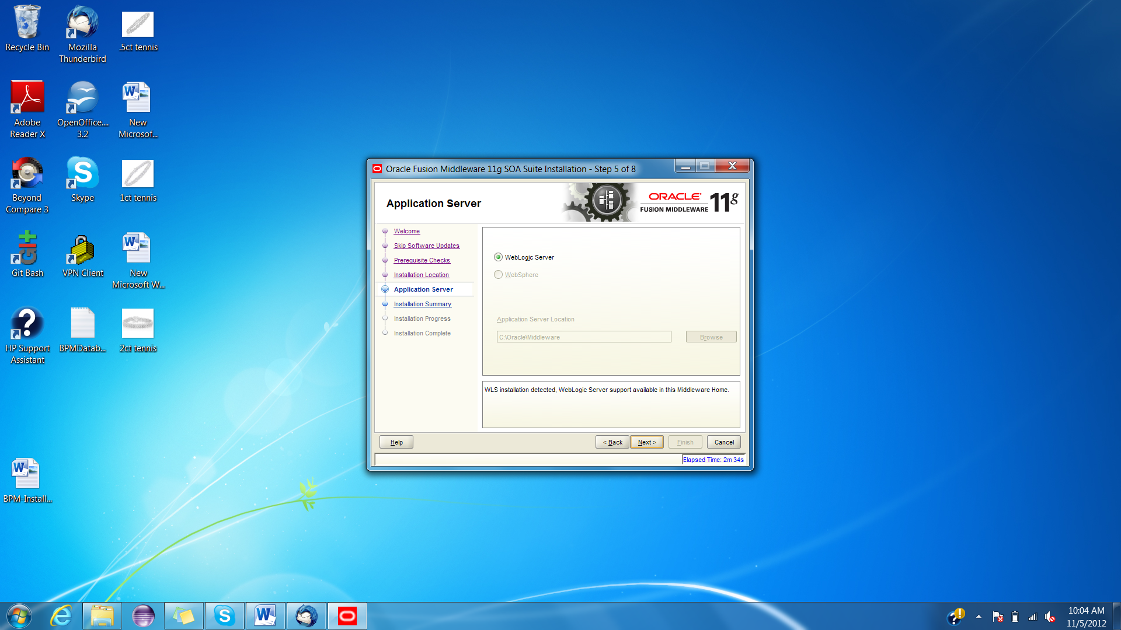

1. Click ‘Install’.

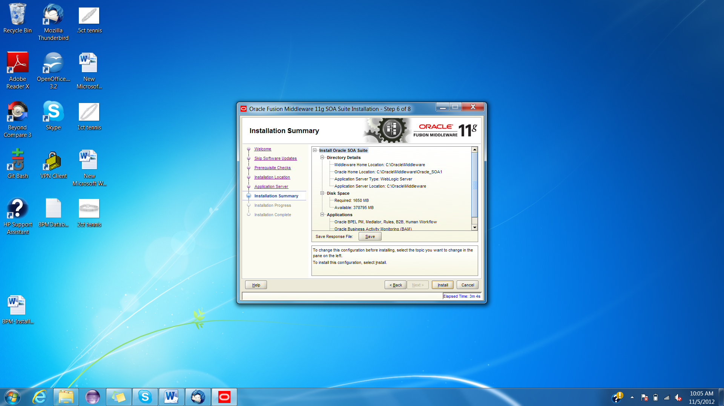

1. Click ‘Next’.

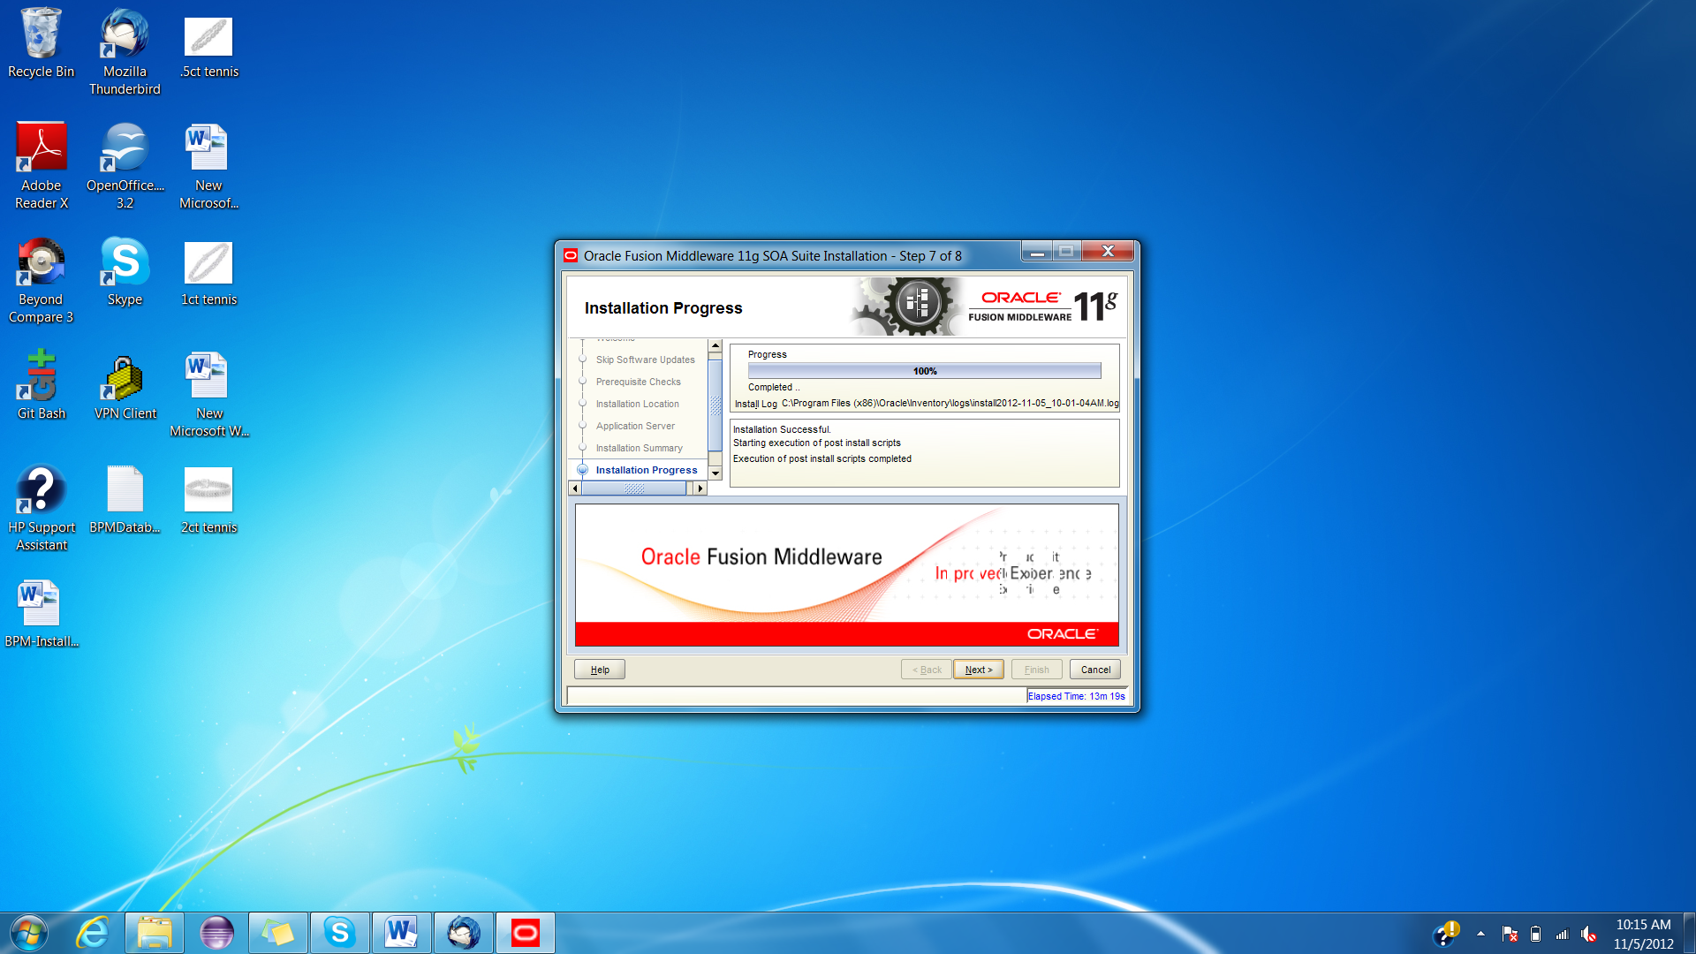

1. Click ‘Finish’.

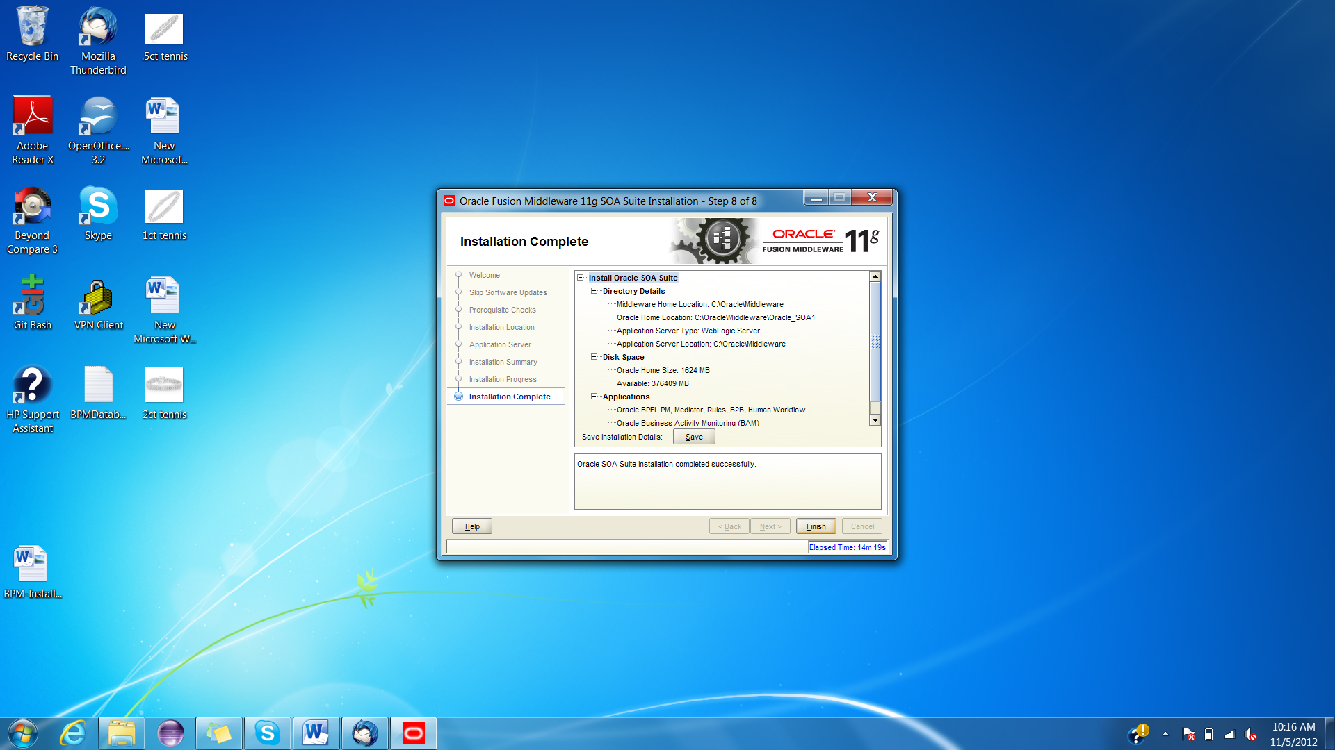

### Creating Weblogic domain and configuring SOA suite

1. Run the configuration wizard located in Oracle_SOA_HOME\common\bin\config.cmd.
2. Select ‘Create a new WebLogic domain’ and click ‘Next’.

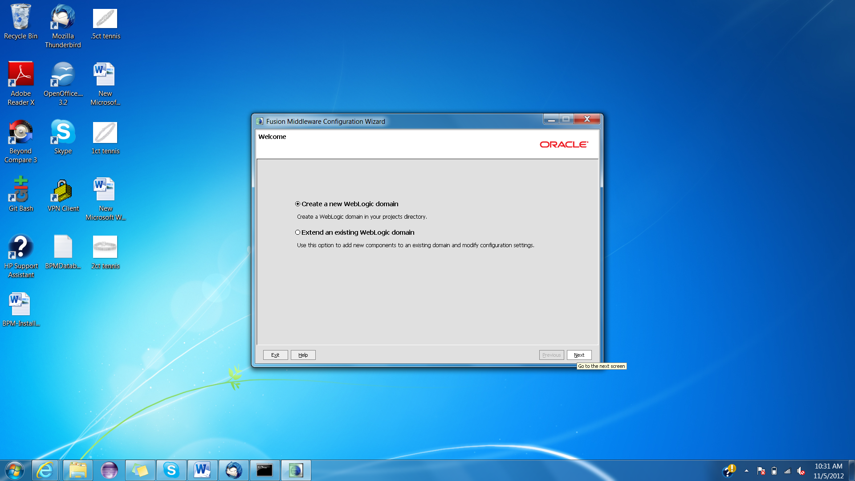

1. Select the radio button ‘Generate a domain configured…’ and select the checkboxes as shown in the screenshot below. Click ‘Next’.

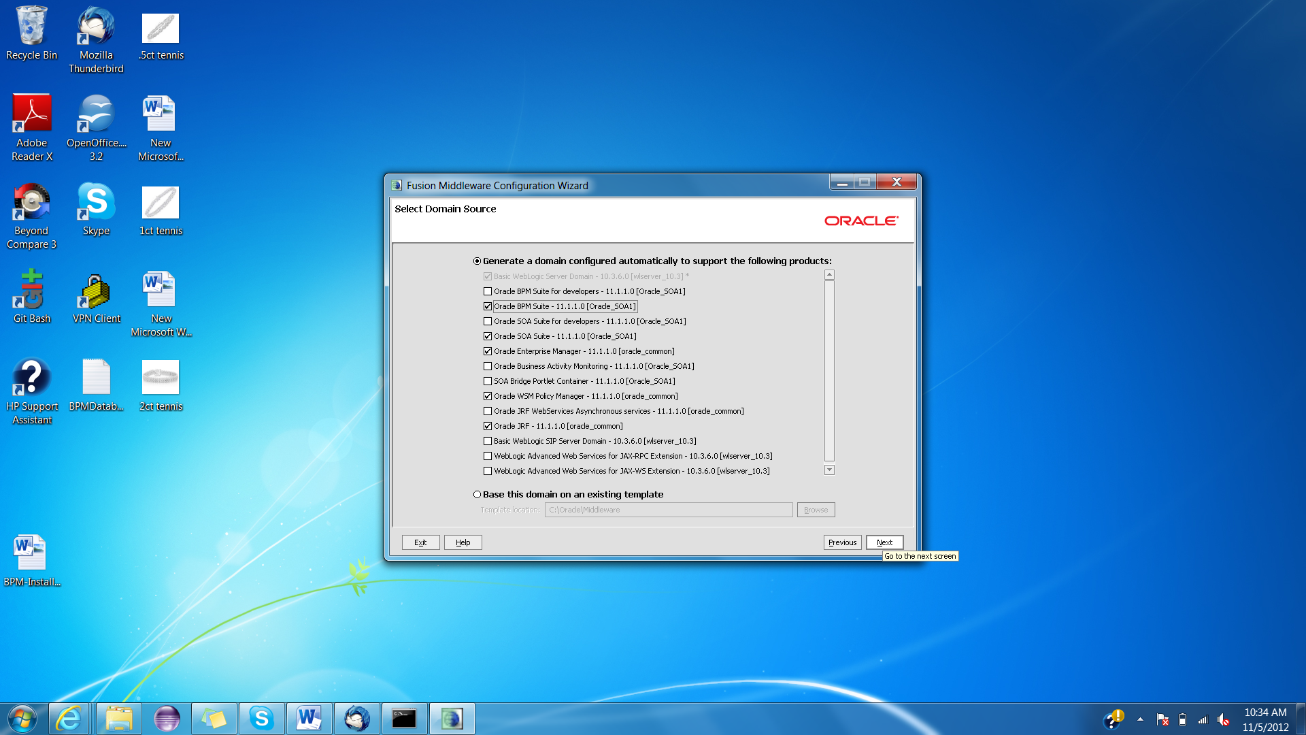

1. Enter the name and location details and click ‘Next’.

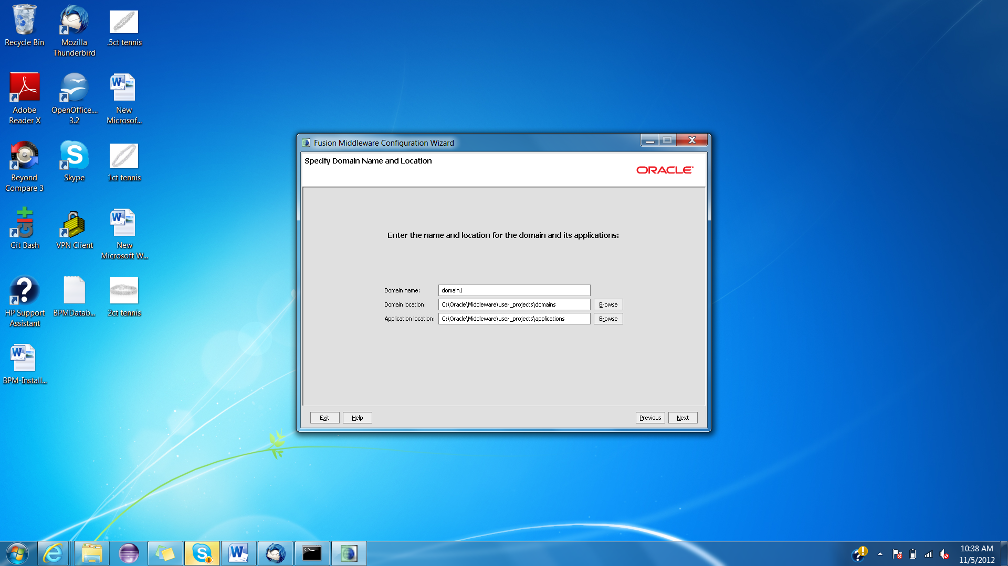

1. Enter login credentials and click ‘Next’.

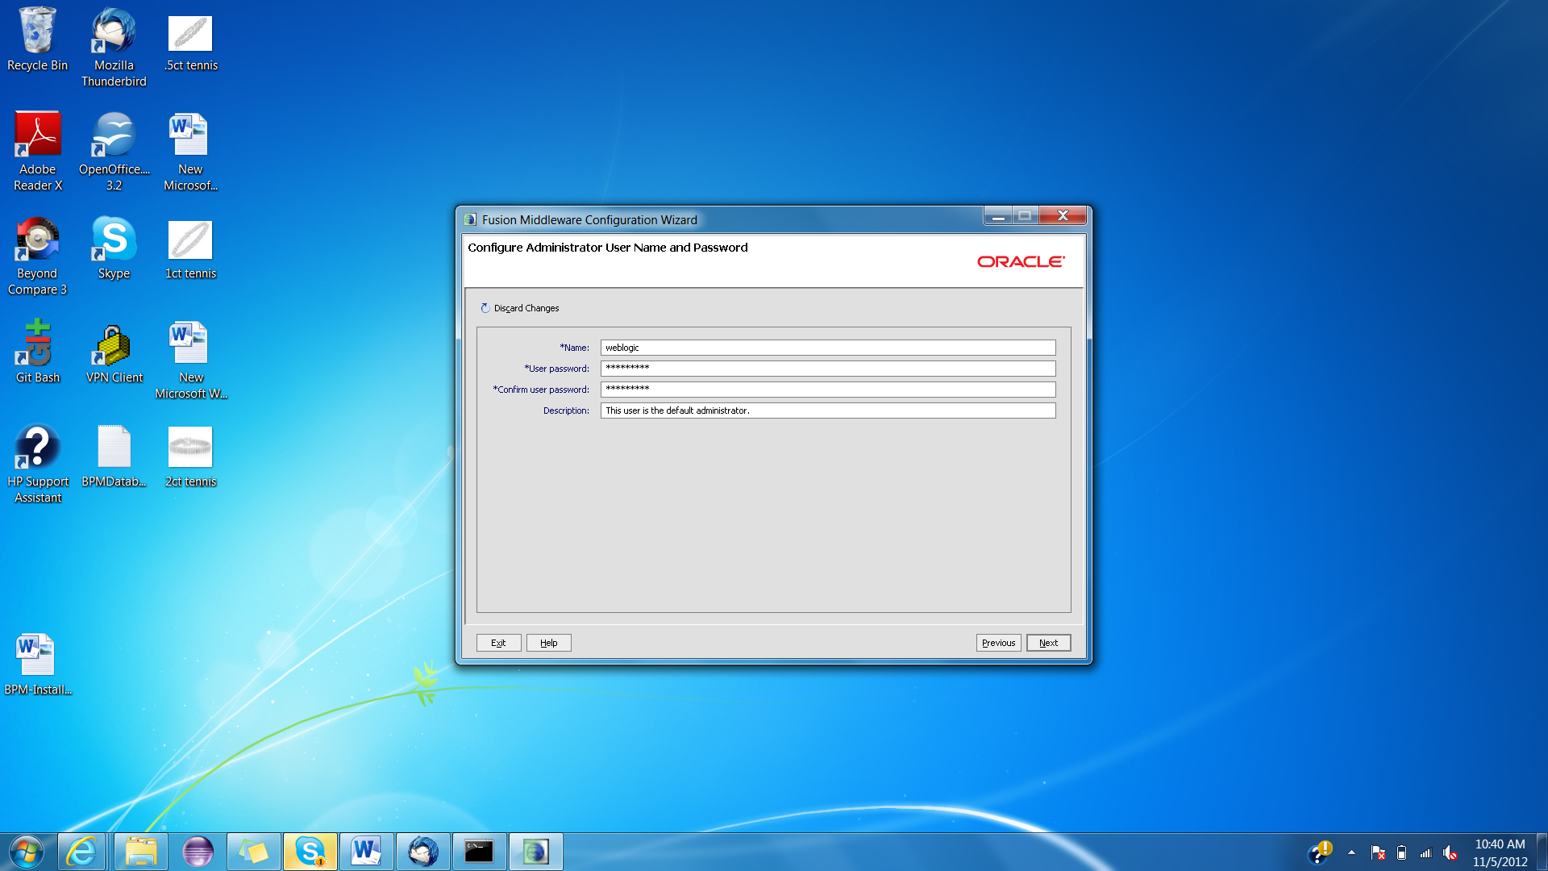

1. Click ‘Next’.

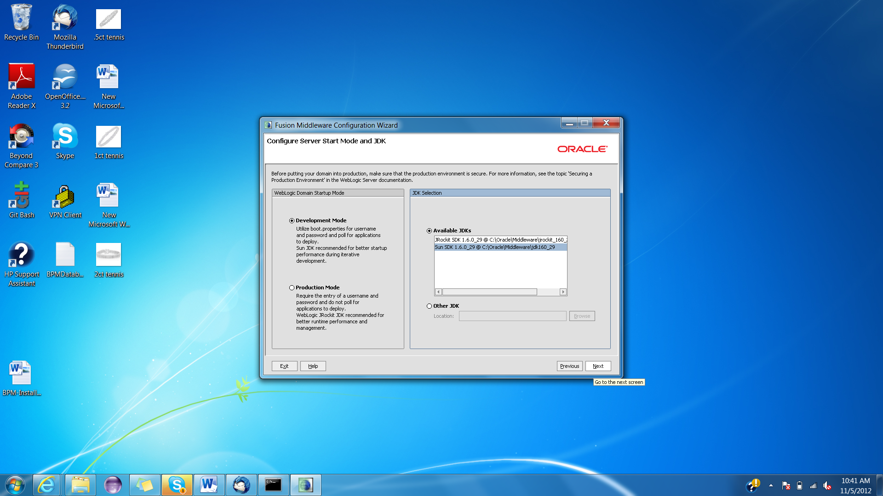

1. Enter the details of the database you had created earlier and click ‘Next’.

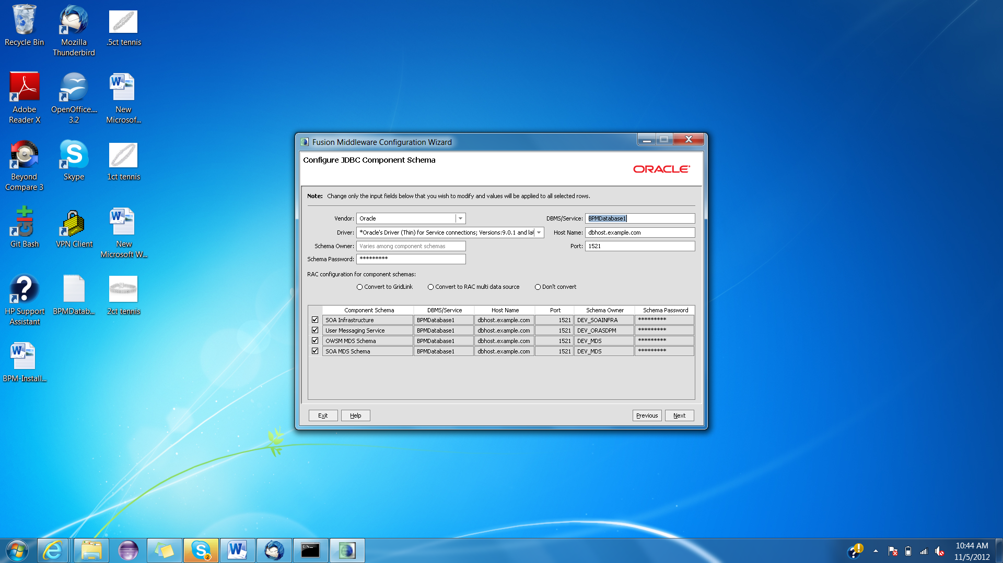

1. Click ‘Next’.

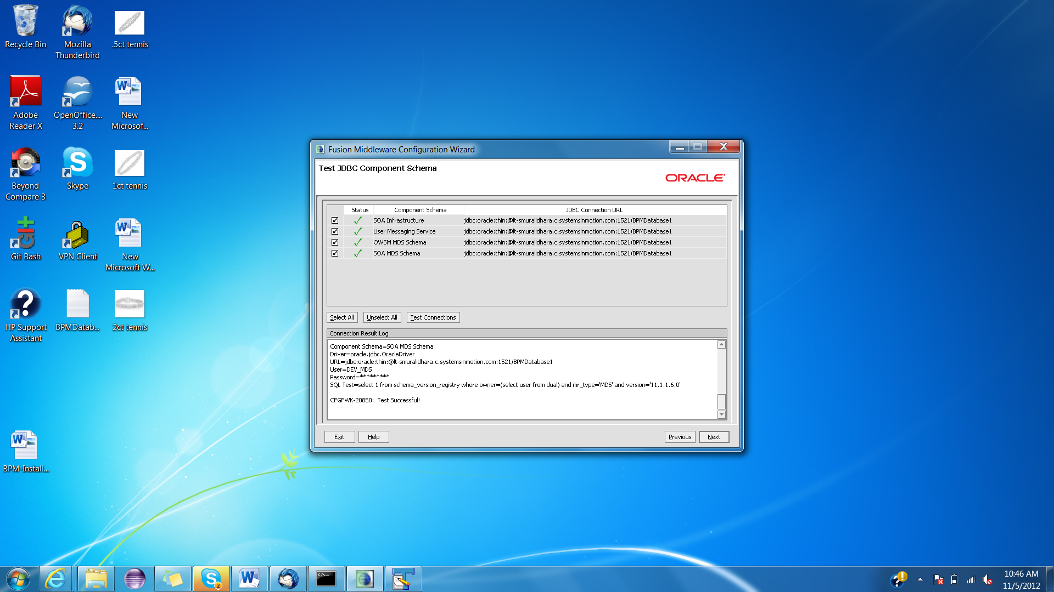

1. Click ‘Next’.

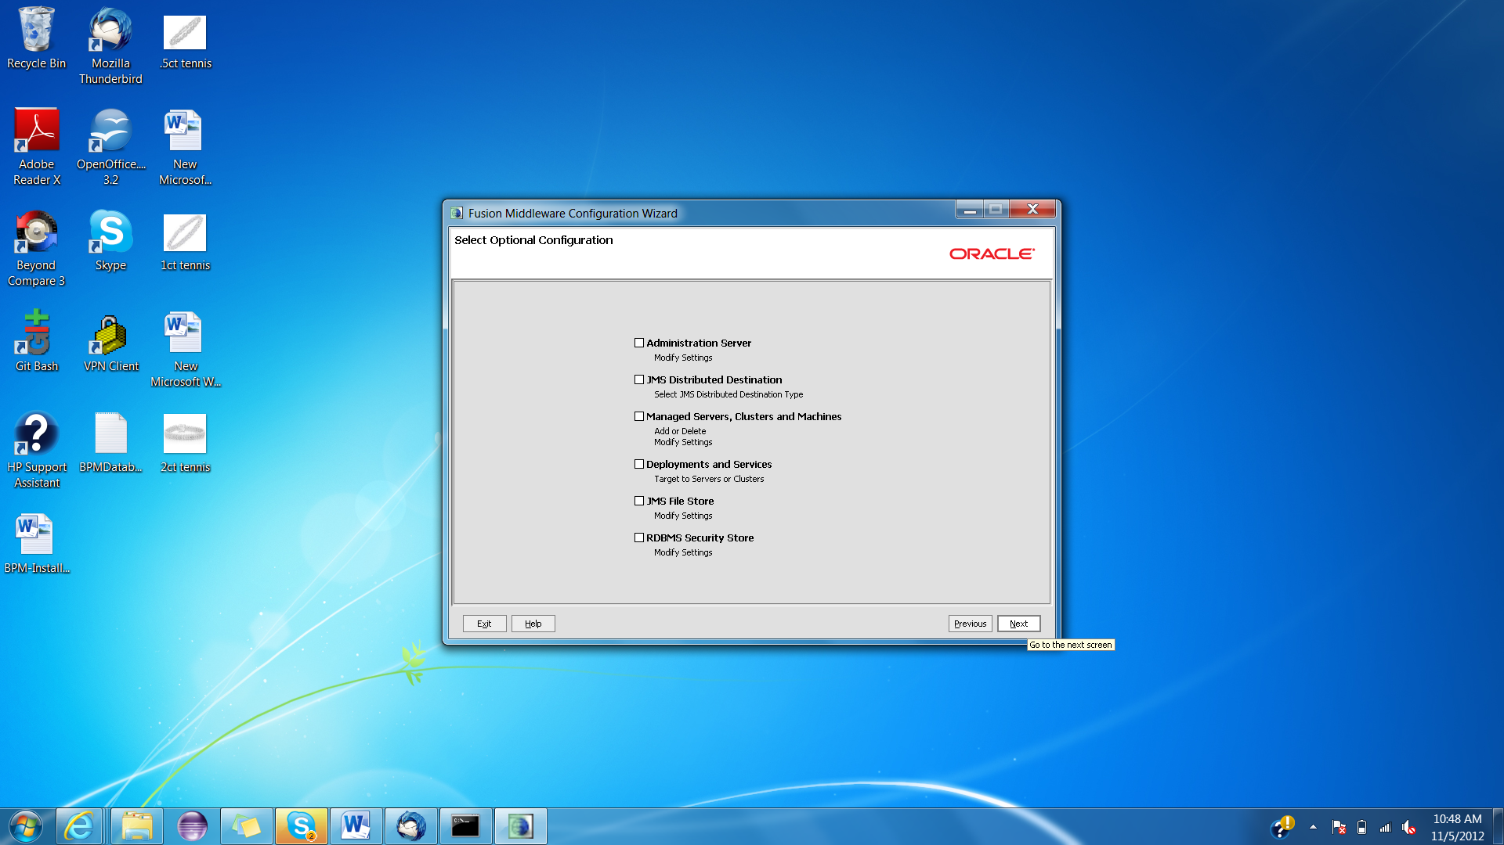

1. Verify all the information and click ‘Create’.

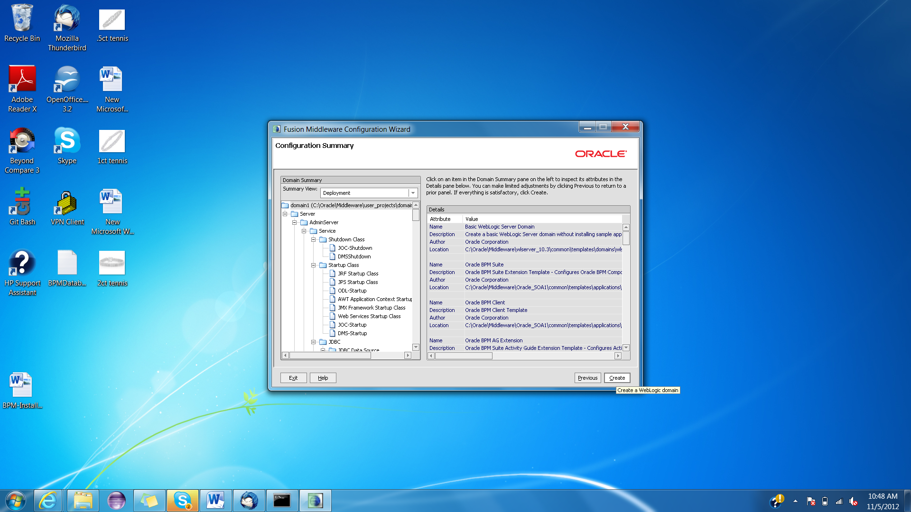

1. Click ‘Done’.

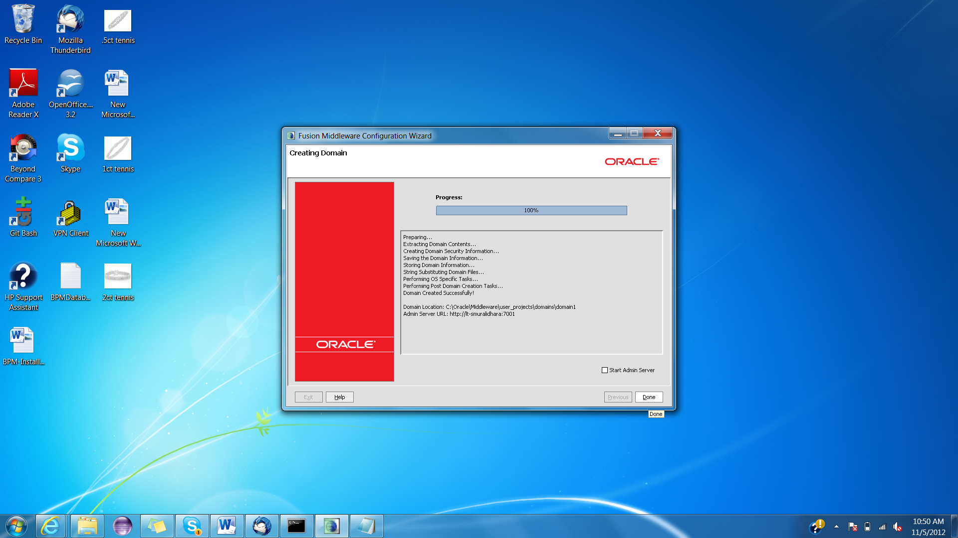

### Updating JDeveloper

1. Start the jdeveloper from Start->All Programs->Oracle Fusion Middleware11.1.1.6.0->JDeveloper Studio 11.1.1.6.0 . Click ‘Ok’.

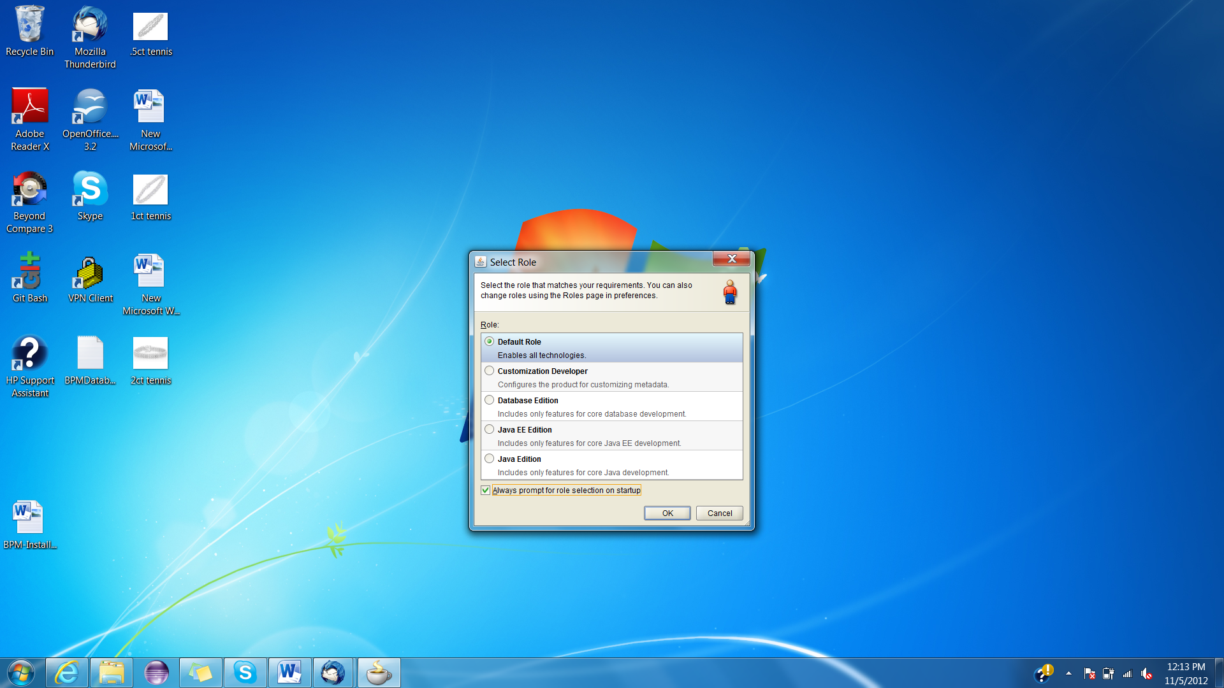

1. Select Help->Check for Updates from the jdeveloper main menu. Click ‘Next’.

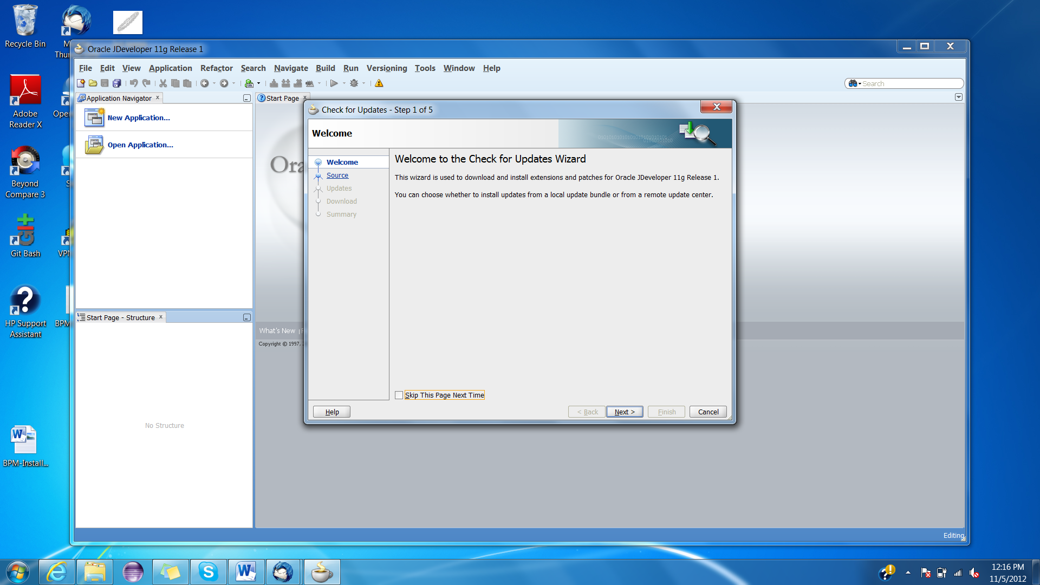

1. Click ‘Next’.

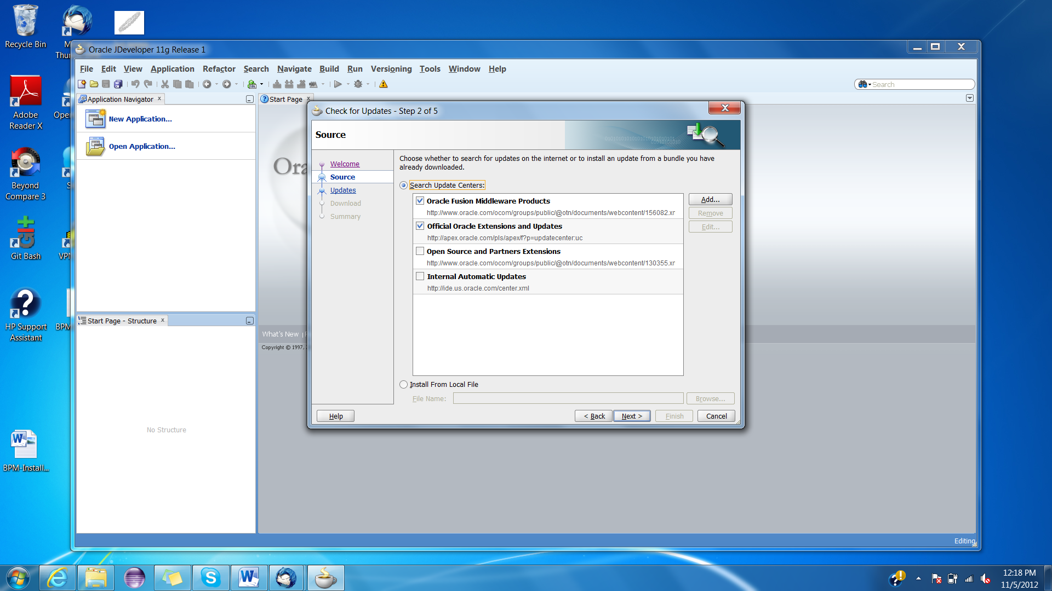

1. Select Oracle BPM Studio and Oracle Composite Editor and click ‘Next’.

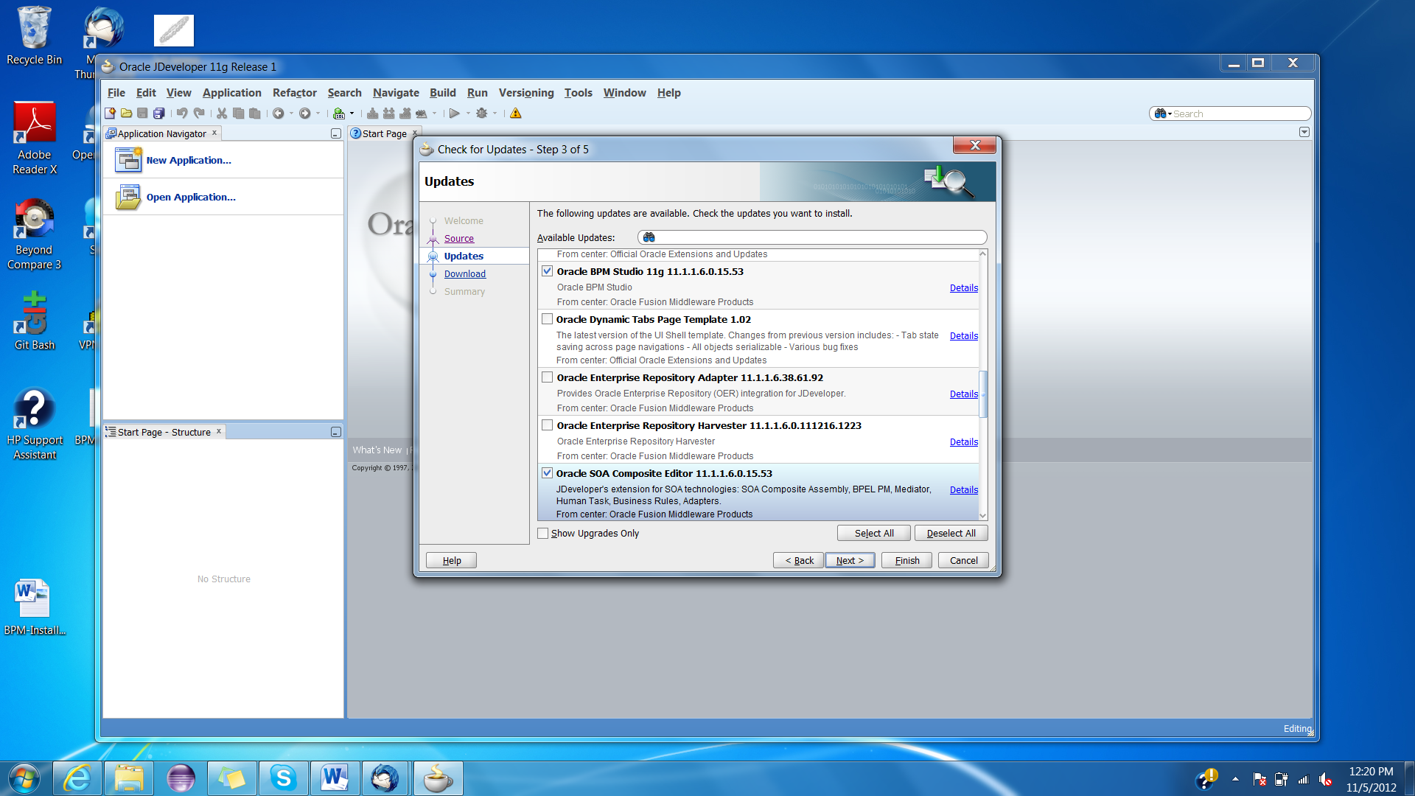

1. Once the updates are installed , click ‘Finish’.

### Installing OSB

1. Download the OSB from oracle site and extract the files.
2. Run the installation setup.

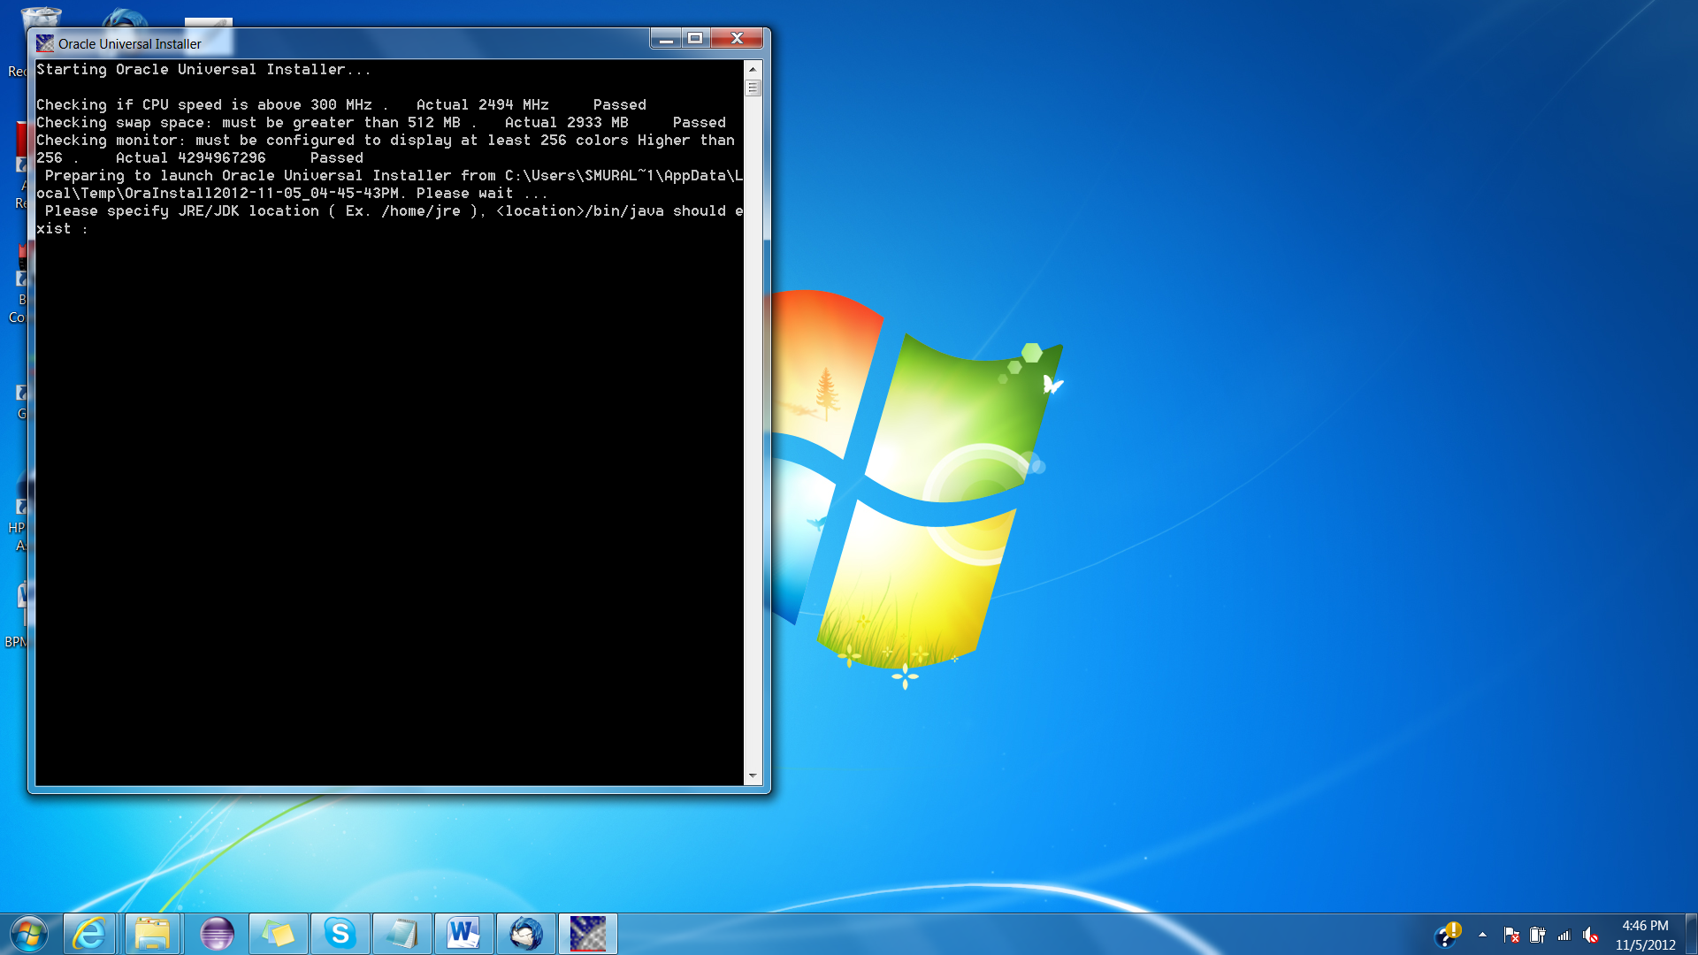

1. Click ‘Next’.

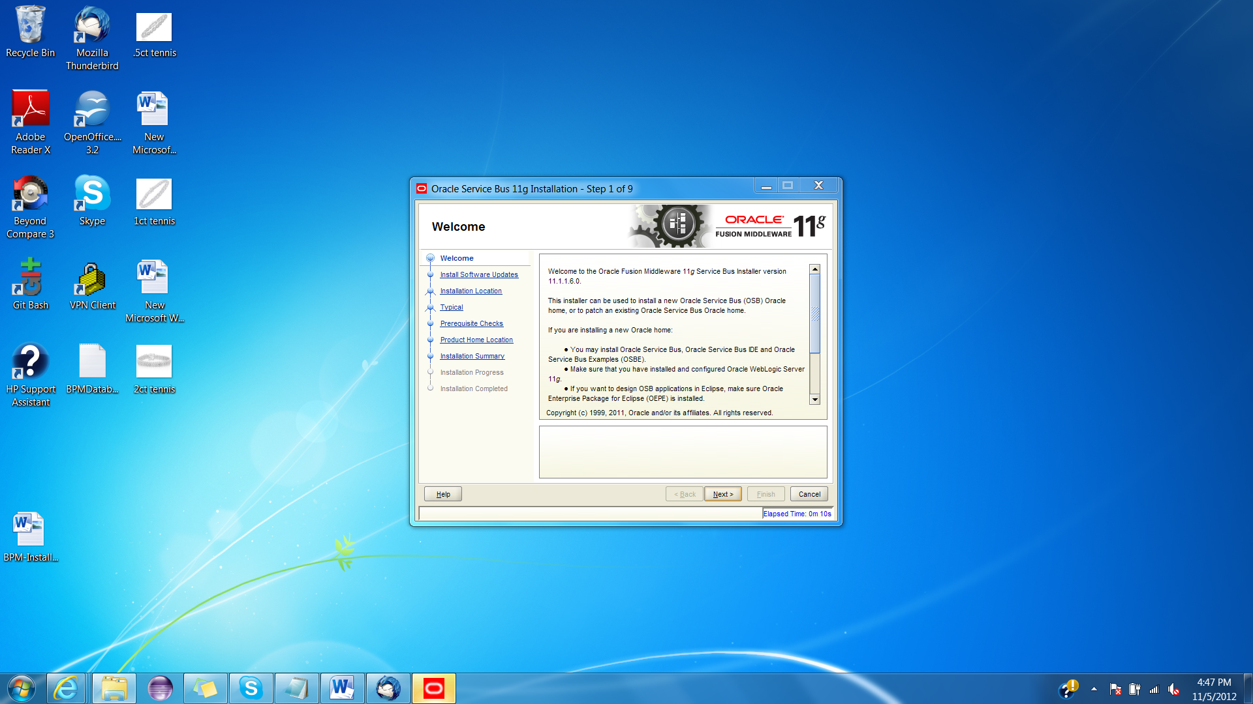

1. Select ‘Skip Software Updates’ and click ‘Next’.

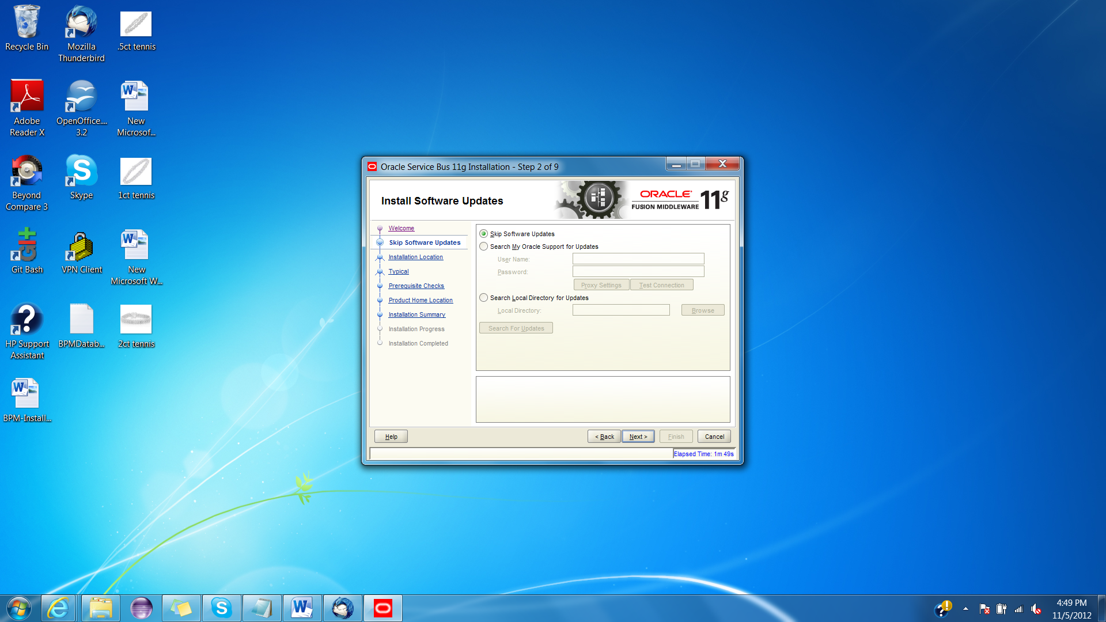

1. Click ‘Next’.

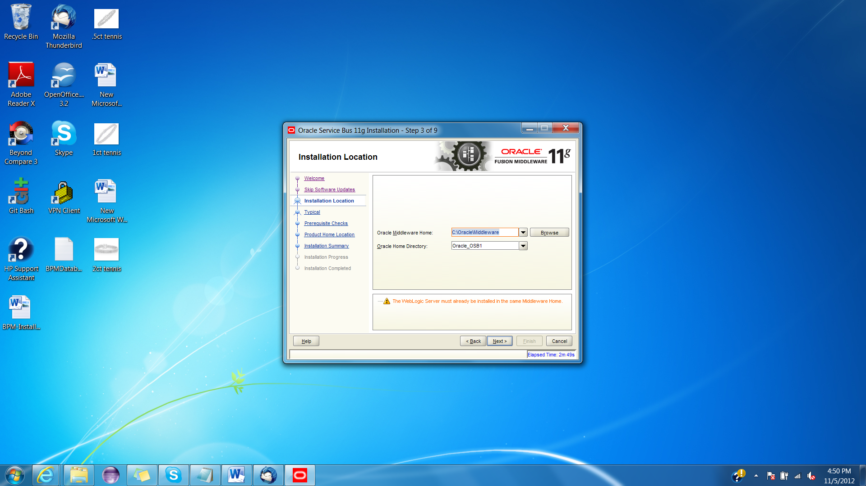

1. Click ‘Next’.

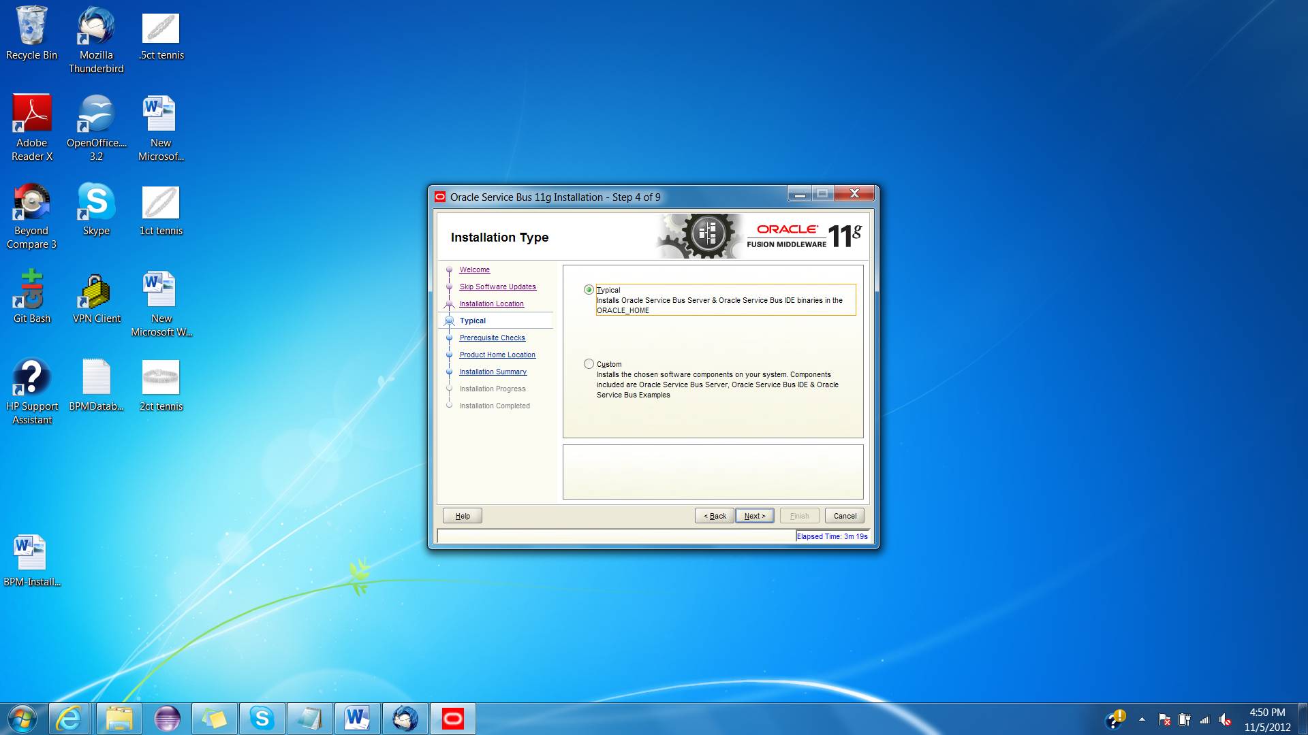

1. Click ‘Next’.

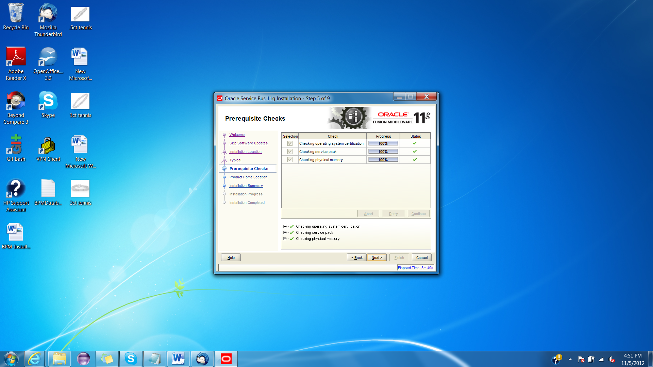

1. Click ‘Next’.

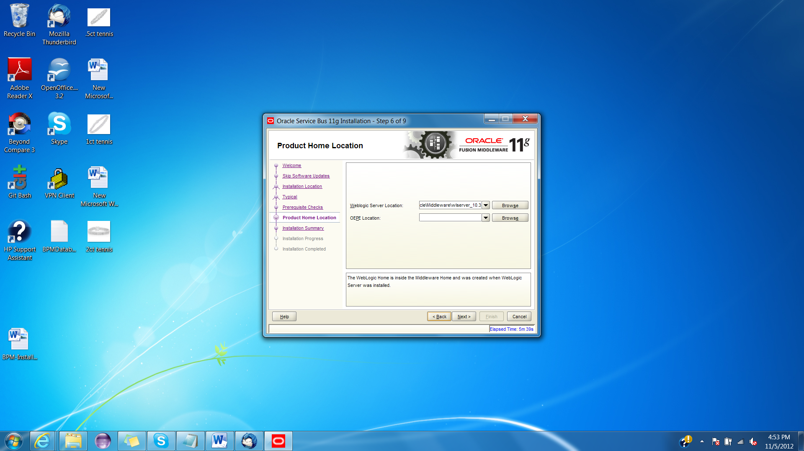

1. Click ‘Install’.

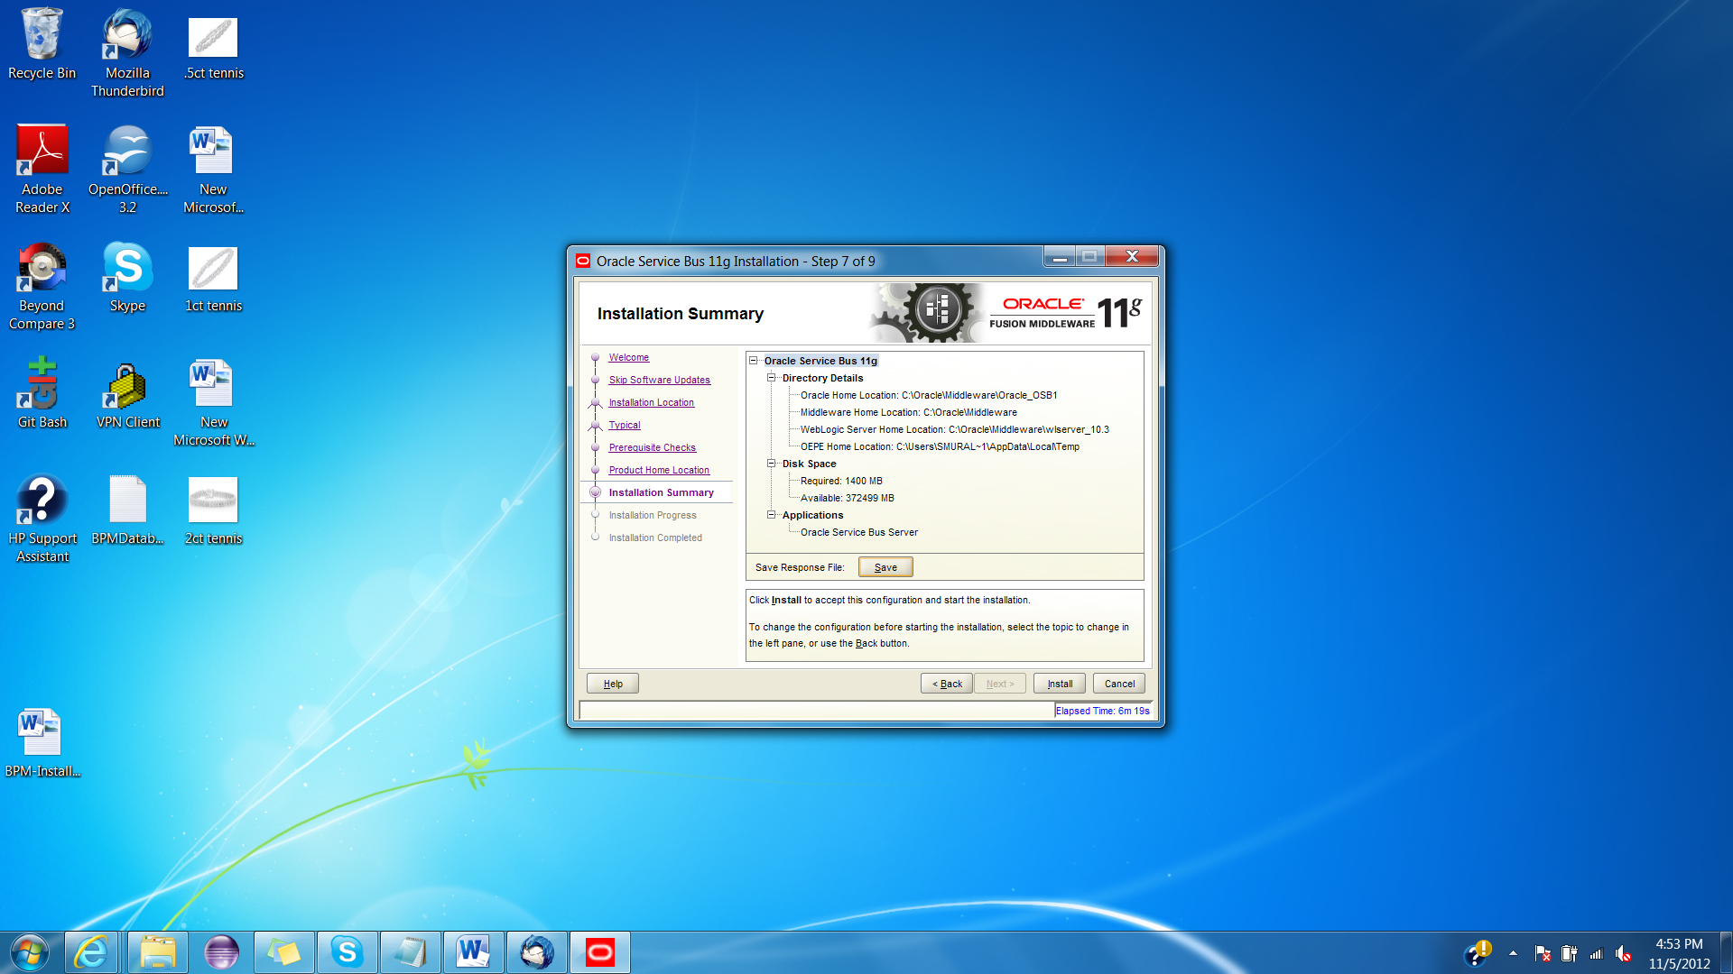

1. Click ‘Next’.

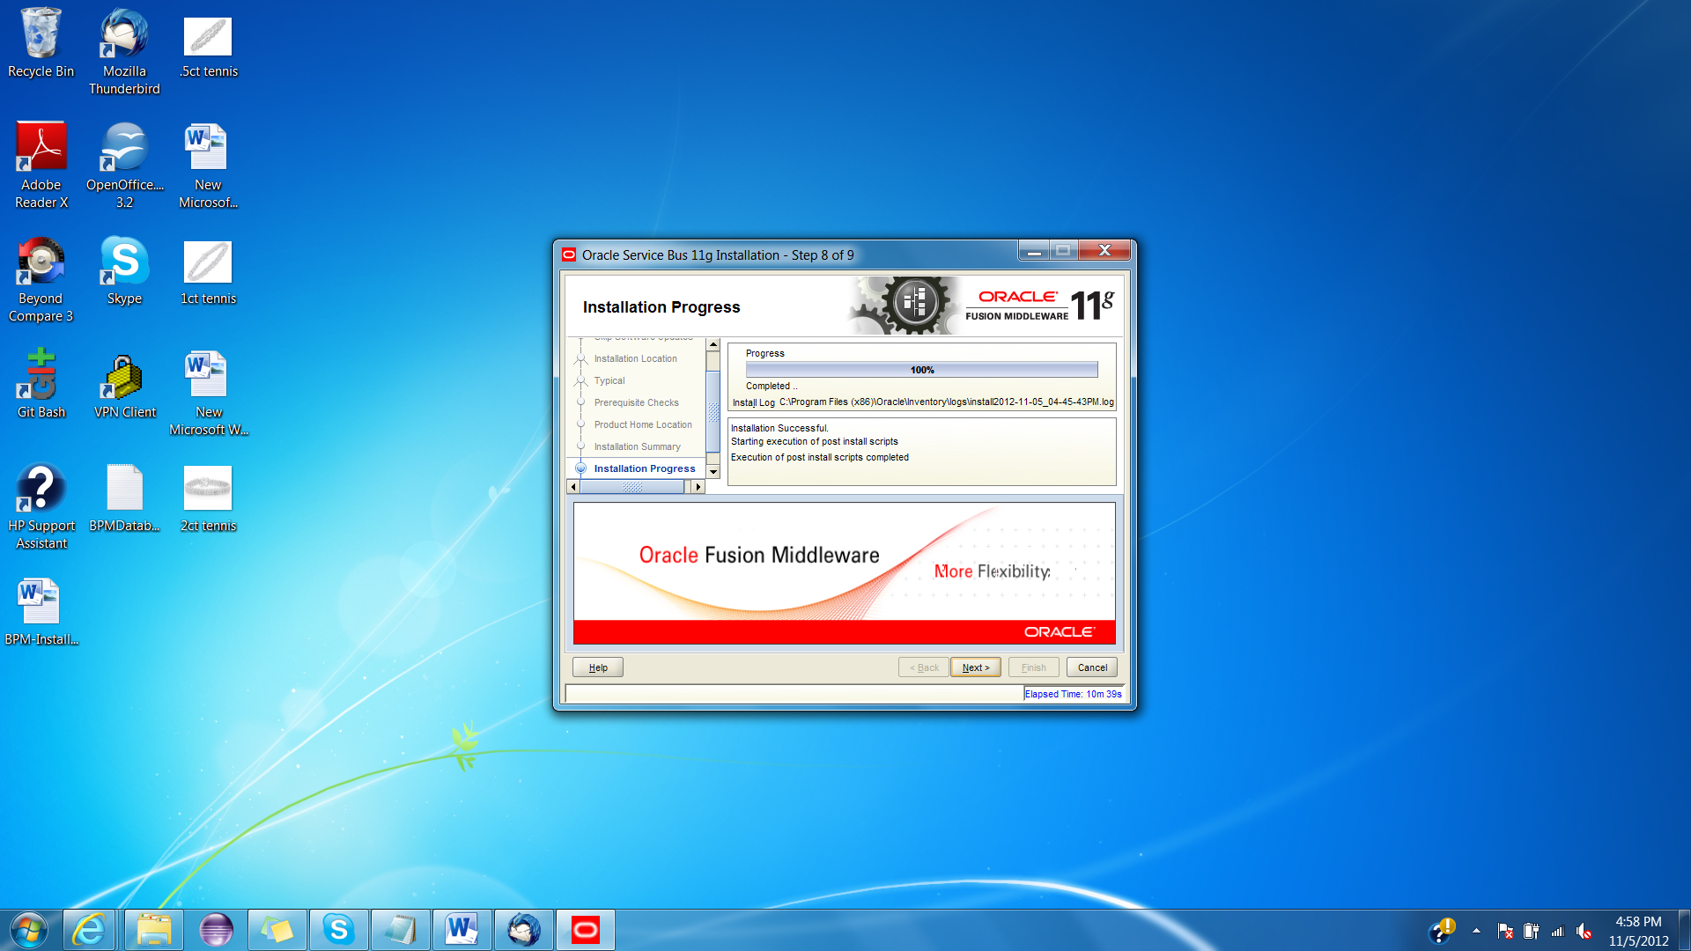

1. Click ‘Finish’.

